Integrated Agrivoltaic–Anaerobic Digestion Optimization Across Four Climate Zones: A Novel Extended Land Equivalent Ratio Framework for Food-Energy-Water Nexus Assessment

[Amidou Maiga]
[Institution, Country]
[Corresponding author email]

Abstract
This study develops and applies an integrated optimization framework coupling bifacial agrivoltaic (APV) systems with on-farm anaerobic digestion (AD) across four climatically distinct sites: Konya, Turkey (BSk, cold semi-arid), Almería, Spain (BSh, hot semi-arid), Ouagadougou, Burkina Faso (BSh, tropical semi-arid), and Freiburg im Breisgau, Germany (Cfb, oceanic temperate). Freiburg is included to extend the climate gradient into the world's largest agricultural biogas market — Germany produced 329 PJ of combined biogas and biomethane in 2024 — and to enable direct comparison with the Italian APV-AD optimization study of Nik Zad et al. (2026). Hourly Typical Meteorological Year data from the PVGIS-SARAH3 database drive a coupled simulation that simultaneously models bifacial PV power generation, tomato crop yield under partial shading via seasonal PAR integration, evapotranspiration reduction, anaerobic biogas production from crop residues with Arrhenius temperature correction, and digester thermal management. Six design variables — panel tilt angle, row spacing, module height, digester volume, hydraulic retention time, and PV heating fraction — are jointly optimized using differential evolution to maximize a novel three-component extended Land Equivalent Ratio $\left(eLER = LER_{crop}+ LER_{PV}+ LER_{biogas}\right)$. Site-specific tomato yields are used: 60 t/ha for the three irrigated semi-arid sites and 30 t/ha for Freiburg, following German open-field production statistics (DLG, 2023). Optimized eLER values reach 1.963 at Konya, 2.293 at Almería, 2.293 at Ouagadougou, and 2.032 at Freiburg — all exceeding the published maximum two-component LER of 1.94 (Riaz et al., 2022). Annual BMP averages span 148.8 NmL CH₄/g VS (Freiburg) to 300.0 NmL CH₄/g VS (Ouagadougou), quantifying the Arrhenius suppression effect across the climate gradient. Biomethane grid injection (Scenario S5) generates the largest economic gains at all sites. Both model validations exhibit conservative biases, confirming that all reported eLER and economic figures represent lower bounds on actual system performance. These results establish that integrated APV-AD systems deliver climate-robust, multi-output land productivity across semi-arid and temperate agroecosystems, and provide the first systematic four-climate-zone quantification of the food-energy-water trade-off using a unified land-efficiency metric.
Keywords: agrivoltaics; anaerobic digestion; extended Land Equivalent Ratio; food-energy-water nexus; differential evolution; semi-arid; temperate; Konya; Almería; Ouagadougou; Freiburg; biomethane

1. Introduction
By 2050, global food production must increase by roughly 50% to feed a population approaching ten billion, while freshwater withdrawals for agriculture — already consuming 70% of the world's accessible freshwater — are expected to intensify further (FAO, 2017; Scanlon et al., 2023). In semi-arid regions, this pressure arrives on top of a pre-existing deficit: potential evapotranspiration already exceeds precipitation for most of the year, making every millimeter of saved irrigation water economically and ecologically significant. Meanwhile, the energy sector faces its own transition, with solar photovoltaics emerging as the lowest-cost source of new electricity generation in many of these same regions (Renewable Power Generation Costs in 2022, 2022). The tension between solar deployment and agricultural land is real and growing; large ground-mount installations can displace food production from productive soils, replacing one resource challenge with another (Dinesh & Pearce, 2016).
Agrivoltaics — the co-location of photovoltaic modules and crops on the same land parcel — was conceived precisely to dissolve this tension (Dupraz et al., 2011; Goetzberger & Zastrow, 1982). Panels elevated above crops generate electricity while the partial shade they cast reduces heat stress, curbs soil moisture evaporation, and can raise crop yields for species adapted to moderate shade. A growing body of field evidence confirms this dual benefit across crop species, climates, and panel configurations (Barron-Gafford et al., 2019; Semeraro et al., 2024). Published two-component LER values for agrivoltaic systems range from 1.2 to 1.94, meaning the combined system outperforms two separate monocultures by 20 to 94% on the same land (Mazzeo et al., 2025; Riaz et al., 2022).
What agrivoltaics alone does not address is what happens after harvest. A one-hectare tomato farm in a semi-arid climate generates roughly 48 tonnes of fresh residues each season — stems, leaves, roots, and culled fruit — most of which are either burned, landfilled, or composted at low efficiency. Anaerobic digestion (AD) converts this organic stream into two valuable outputs: biogas, a storable and dispatchable energy carrier, and digestate, a nutrient-rich biofertilizer that can replace synthetic inputs (Möller & Mü(Huld et al., 2012)ller, 2012). The pairing between an agrivoltaic system and an on-farm digester is compelling: the PV electricity stabilizes digester temperature, the digester processes the residues that the agrivoltaic field generates, and the digestate returns macronutrients to the soil beneath the panels. The circle closes.
The strategic importance of agricultural biogas extends beyond individual farm economics. Germany produced 329 PJ of combined biogas and biomethane in 2024, with approximately 8,000 agricultural plants contributing roughly 80% of that total (IEA, 2025; EBA, 2025). The REPowerEU Plan sets a non-binding target of 35 billion cubic metres of sustainable biomethane per year by 2030, accompanied by an estimated investment need of €37 billion (European Commission, 2022). The Renewable Energy Directive (RED III) and Germany's Renewable Energy Sources Act (EEG 2023) provide feed-in premiums for biomethane grid injection, where the market value is approximately 5.5 times the electricity purchase price in Central European markets (Nik Zad et al., 2026; Rabobank, 2025).
Despite the logical complementarity of these two technologies, research has so far treated them in isolation. Agrivoltaic optimization studies focus on panel geometry, crop PAR, and energy yield, but ignore the residue stream entirely (Riaz et al., 2022; Zainali et al., 2023). Anaerobic digestion studies model heating energy supply but treat the agricultural component only as a passive feedstock source (Pal & Ilango, 2024; Temiz et al., n.d.). Most critically, no study prior to this work has proposed a unified performance metric that captures food, electricity, and biogas outputs on the same land-use basis.
A concurrent study by Nik Zad et al. (2026), published in Energy Conversion and Management, represents an important step toward this integration, applying a multi-objective genetic algorithm combined with TOPSIS to optimize the techno-economics of an agrivoltaic-powered biomethane plant in Italy. Their key finding — that heat pump electrification achieves up to 8.7 times higher NPV than conventional biogas combustion by preserving biogas for grid injection — directly motivates the inclusion of a biomethane upgrading scenario (Scenario S5) in the present study. However, Nik Zad et al. (2026) do not address five dimensions that this study targets: (i) a novel eLER metric capturing food, electricity, and biogas on a consistent dimensionless basis; (ii) explicit modelling of crop yield as a co-produced output via the seasonal PAR integral; (iii) a multi-climate analysis spanning four Köppen climate zones on three continents; (iv) Arrhenius-corrected seasonal biogas yield quantifying the thermal challenge of cold-continental and temperate digesters; and (v) evapotranspiration-based water savings as a quantified nexus component.
This paper addresses these gaps directly. We present an integrated optimization framework that simultaneously designs the agrivoltaic architecture and the anaerobic digestion subsystem for a given climate and crop, and propose the eLER that adds biogas as a third component to enable consistent, multi-output land productivity assessment. The framework is applied to four sites spanning three continents and four Köppen climate subtypes.
The specific contributions of this work are:
- Contribution 1 — Integrated six-variable optimizer: a differential evolution optimizer jointly searches the APV design space (tilt angle, row spacing, module height) and the AD design space (digester volume, hydraulic retention time, PV heating fraction), with both models driven by the same hourly PVGIS-SARAH3 climate data.
- Contribution 2 — Three-component eLER metric: the eLER extends the classical two-component LER to include net biogas energy as a third dimensionless component, enabling direct comparison of APV-AD land productivity against AV-only and AD-only monoculture references.
- Contribution 3 — Four-climate-zone analysis: the framework is applied to Konya (BSk), Almería (BSh), Ouagadougou (BSh), and Freiburg (Cfb), extending the analysis into the world's largest agricultural biogas market and enabling direct comparison with Nik Zad et al. (2026).
- Contribution 4 — Climate-sensitive biogas characterization: the first quantification across four climate zones of how seasonal ambient temperature suppresses biogas yield through Arrhenius correction, with simulated BMP averages spanning 148.8 to 300.0 NmL CH₄/g VS.
- Contribution 5 — Biomethane valorization scenario: Scenario S5 values biogas at the European biomethane market premium (5.5× electricity price), enabling direct economic comparison with Nik Zad et al. (2026).
- Contribution 6 — Water savings characterization: seasonal ET reductions under optimized panel configurations are quantified at all four sites, with the $eLER–LER_{water}$ Pareto trade-off resolved at Konya (the only site with sufficient seasonal variation for a genuine bi-objective front).

The paper is organized as follows. Section 2 reviews the relevant literature and identifies the six research gaps addressed. Section 3 presents the integrated modelling framework. Section 4 reports the simulation results for all four sites. Section 5 discusses design implications and limitations. Section 6 concludes.

2. Related Work
This section reviews the state of the art in three interconnected domains: agrivoltaic systems (Section 2.1), anaerobic digestion of agricultural residues (Section 2.2), and integrated agrivoltaic-biogas systems (Section 2.3). Section 2.4 synthesizes these threads to identify the specific gaps this study addresses.

2.1. Agrivoltaic Systems: From Concept to Optimization

2.1.1. Early demonstrations and proof of concept
The modern concept of agrivoltaics was formalized by Dupraz et al. (2011), who demonstrated at INRA Montpellier that combining PV with crops could increase land productivity by 35–73% compared to separate monocultures. Subsequent field trials consistently documented: reductions in crop evapotranspiration of 20–40% under panels; decreases in soil surface temperature of 1.5–3.0°C; increases in water-use efficiency of 30–60%; and crop yield reductions ranging from 5% for shade-adapted species to 40% for highly light-demanding crops (Barron-Gafford et al., 2019; Elamri et al., 2018; Hassanpour Adeh et al., 2018; Weselek et al., 2019).

2.1.2. Architectural evolution and system optimization
As the field matured, researchers moved beyond the original fixed-tilt overhead configuration to explore a range of panel geometries and tracking strategies (Table 1). Riaz et al. (2022) introduced the Light Productivity Factor as a unified metric for crop-PV co-optimization, demonstrating that bifacial modules with optimized row spacing achieve LER values of 1.2–1.5 for tomato in semi-arid conditions — the same crop and climate context central to the present study.

Table 1. Agrivoltaic system architectures and their principal characteristics.
Table 1 : Agrivoltaic system architectures and their principal characteristics.
Architecture | Description | Crop compatibility | Energy yield (kWh/kWp) | Key reference
Fixed-tilt overhead | Panels at constant angle, 3–5 m height | Most annual crops | 1,200–1,400 | Dupraz et al. (2011)
Single-axis tracking | Panels rotate east-west | Tall crops (maize, sorghum) | 1,400–1,600 | Imran et al. (2020)
Dual-axis tracking | Full sun tracking | Very tall crops, orchards | 1,600–1,800 | Ravilla et al. (2024)
PV greenhouse | Semi-transparent roof | Protected vegetables | 800–1,200 | Gorjian et al. (2022)
Vertical bifacial | Panels vertical, east-west facing | Arable crops, machinery access | 1,000–1,300 | Chalgynbayeva et al. (2023)

2.1.3. Microclimate modification and water savings
Mohammedi et al. (2023) found that tomato crops under AV panels in southern Italy experienced a 16–21% reduction in reference ET₀, a 2.3°C decrease in maximum daily soil temperature, and a 7–14 days extension of the effective growing season. Semeraro et al. (2024) synthesized evidence from 23 independent AV field studies and concluded that shading reduces irrigation requirements by 15–35%. The empirical ET reduction coefficient $α_{shade}= 0.40$ from Tawassulli (2025), lying within the 0.30–0.50 range of Elamri et al. (2018), is adopted in the present model (Eq. 14).

2.1.4. The Land Equivalent Ratio as a performance metric
The LER was originally developed for intercropping systems by Mead and Willey (1980). For a two-component agrivoltaic system:
$$\begin{aligned}LER=\frac{Y_{crop,AV}}{Y_{crop,open}}+\frac{E_{PV,AV}}{E_{PV,open}}\#\left(1\right)\end{aligned}$$

where Y represents crop yield and E represents electricity production. Published LER values range from 0.95 to 1.94 (Table 2). Riaz et al. (2022) reported LER = 1.94 for tomato under optimized bifacial arrays in semi-arid conditions — the highest published value and the benchmark used in this study.
Table 2 : Representative two-component LER values from experimental and modelling studies.
Study | Location | Crop | LER | System type
Dupraz et al. (2011) | France | Durum wheat | 1.35 | Fixed-tilt, modelled
Amaducci et al. (2018) | Italy | Maize | 1.28 | Fixed-tilt, experimental
Mohammedi et al. (2023) | Italy | Tomato | 1.42 | Fixed-tilt, experimental
Riaz et al. (2022) | USA (AZ) | Tomato | 1.94 | Bifacial, optimized
Mazzeo et al. (2025) | Italy | Lettuce | 1.85 | Open-field, optimized
Semeraro et al. (2024) | Multi-site | Various | 1.20–1.60 | Meta-analysis

2.2. Anaerobic Digestion of Agricultural Residues

2.2.1. Feedstock characterization and methane potential
The biochemical methane potential (BMP) quantifies the maximum volumetric methane yield per unit of volatile solids in a substrate (Angelidaki et al., 2009). Feng et al. (2013) reported BMP values of 250–350 NmL CH₄/g VS for tomato residues, and Lallement et al. (2023) established 300 NmL/g VS as the representative central value for mixtures with branches below 20% — the condition assumed in this study (Table 3).

Table 3 : Biochemical methane potential of agricultural residues relevant to agrivoltaic systems.
Substrate | BMP (NmL CH₄/g VS) | Lignocellulose content | Reference
Cattle manure | 200–280 | Low | Lallement et al. (2023)
Tomato residues | 250–350 | Medium-high | Lallement et al. (2023)
Cereal straw | 230–320 | High | Pilarski & Pilarska (2025)
Vegetable mixtures | 200–400 | Variable | Pilarski & Pilarska (2025)

2.2.2. Temperature effects and process kinetics
The temperature dependence of BMP follows an Arrhenius-type relationship (Lindorfer et al., 2008):
$$\begin{aligned}BMP\left(T\right)= BMP_{ref}∙exp\left[θ∙ \left(T - T_{ref}\right)\right]\#\left(2\right)\end{aligned}$$
where θ = 0.069 °C⁻¹ (Pilarski & Pilarska, 2025) for mesophilic digestion of agricultural residues, consistent with values reported by Lindorfer et al. (Lindorfer et al., 2008). This relationship is central to the present model, directly linking the ambient temperature climate to achievable biogas yield — an effect particularly pronounced at Konya ($T_{min}≈ -18°C$) and Freiburg $(T_{min} ≈ -12°C$).

2.2.3. Co-digestion and process stability
Anaerobic co-digestion of carbon-rich tomato residues with nitrogen-rich substrates such as cattle manure can increase methane yield by 20% or more (Wang et al., 2018; Pilarski & Pilarska, 2025), captured here as Scenario S1 (BMP multiplier = 1.15). Process stability is monitored via the volatile fatty acids to alkalinity ratio (VFA/Alk < 0.3; Marchaim, 1992).

2.3. Integrated Agrivoltaic-Biogas Systems

2.3.1. Thermal coupling of PV and AD
Pal and Ilango (2024) found that integrated PV heating reduced required PV capacity by 65% and battery storage by 52% compared to a non-heated reference system. Temiz et al. (n.d.) demonstrated that solar thermal integration can save 30–40% of the biogas otherwise consumed for digester self-heating. Both studies, however, treat AV and AD as subsystems with essentially unidirectional energy flow and do not consider the full circular loop in which crop residues feed the digester and digestate fertilizes the crops.

2.3.2. The Nik Zad et al. (2026) optimization framework
A landmark study in Energy Conversion and Management by Nik Zad et al. (2026) presents an optimization framework integrating bifacial APV systems with AD plants for biomethane production in Italy, employing MOGA-TOPSIS across eight scenarios. Heat pump electrification consistently outperformed CHP, achieving up to 8.7× higher NPV; biomethane commands approximately 5.5× the electricity purchase price in Italian markets. The present study complements and extends this work in five directions that Nik Zad et al. do not address: (i) eLER as a land-use metric rather than NPV alone; (ii) crop yield as a co-produced output via the PAR integral; (iii) four climate zones on three continents; (iv) Arrhenius-corrected BMP and seasonal heat balance; and (v) the food-energy-water nexus via ET reduction quantification.

2.3.3. Circular economy and nutrient loops
The digestate fraction of tomato residues contains approximately 3 kg of plant-available nitrogen, 1 kg P₂O₅, and 4 kg K₂O per tonne of fresh residue treated (Mohammedi et al., 2023). On a semi-arid hectare producing 48 t/ha residue annually, this represents a return of ~144 kg N, 48 kg P₂O₅, and 192 kg K₂O — substantial fractions of the synthetic fertilizer requirements for a subsequent tomato crop (Fertilizer Use by Crop, 2006). The digestate valorization scenario (S4) captures the economic value of this N-P-K substitution.

2.3.4. Biogas market context and policy drivers
Germany hosts ~8,000 agricultural plants producing 329 PJ in 2024, while REPowerEU targets 35 bcm of sustainable biomethane by 2030 (IEA, 2025; EBA, 2025; European Commission, 2022). In Sub-Saharan Africa, where grid electricity costs are highest among the study sites (Ouagadougou: $0.12/kWh) and LPG is the primary cooking fuel, on-site biogas displacement offers a disproportionate development benefit beyond its monetary value (IEA Africa Energy Outlook, 2024; REN21, 2025).

2.4. Research Gaps and Study Positioning

2.4.1. What is well established
- AV systems can achieve two-component LER values of 1.2–1.94 across a range of crops, climates, and architectures (Mazzeo et al., 2025; Riaz et al., 2022).
- Partial shading under AV panels reduces crop ET by 15–35% in semi-arid climates (Semeraro et al., 2024; Elamri et al., 2018).
- BMP of tomato residues is 250–350 NmL/g VS, with 300 NmL/g VS as the well-documented central estimate (Feng et al., 2013; Lallement et al., 2023).
- PV electricity can economically supply digester thermal demand, improving overall system efficiency (Pal & Ilango, 2024; Temiz et al., n.d.).
- Biomethane commands a market premium of approximately 5.5× the electricity purchase price in European markets (Nik Zad et al., 2025; EBA, 2025).
- Germany is the world's largest agricultural biogas market with ~8,000 plants and 329 PJ in 2024 (IEA, 2025; EBA, 2025).

2.4.2. Identified research gaps
Six distinct gaps motivate the present study:
- G1 — No unified land-use efficiency metric for integrated APV-AD: LER captures crop and PV outputs but excludes biogas, making cross-system comparisons on a consistent land-use basis impossible.
- G2 — No joint optimization of APV architecture and AD with crop yield co-production: no study has optimized the coupled panel geometry–crop yield–digester performance problem simultaneously.
- G3 — No systematic multi-climate comparison: Nik Zad et al. (2026) analyze one Italian site; no study spans semi-arid and temperate zones systematically.
- G4 — No thermal coupling characterization across the full continental temperature range: the energy balance across cold-continental sites (Konya −18°C; Freiburg −12°C) alongside tropical sites (Ouagadougou $T_{min}> 13°C$) has not been quantified.
- G5 — No food-energy-water nexus quantification: APV water savings have not been integrated into any APV-AD optimization framework as a measured output.
- G6 — No modelling of the AD-to-crop feedback loop: the circular path from crop residues through digestion and back to soil via digestate has not been incorporated in any quantitative optimization.

2.4.3. Positioning of the present study
This study directly addresses gaps G1 through G5. The eLER metric (Section 3.8) closes G1. Joint six-variable optimization (Section 3.9) addresses G2. Four-site application spanning four Köppen subtypes (Section 3.1) addresses G3. Arrhenius-corrected seasonal heat balance (Section 3.7) addresses G4. The ET reduction and $LER_{water}$ calculation (Section 3.6) addresses G5. Gap G6 — field validation of digestate-to-soil nutrient feedback — is identified as a priority for future experimental work (Section 5.5).

3. Methodology

3.1. Study sites and climate characterization
The analysis is anchored to four sites chosen to span distinct climate subtypes within the Köppen–Geiger classification: Konya (Turkey, BSk), Almería (Spain, BSh), Ouagadougou (Burkina Faso, BSh), and Freiburg im Breisgau (Germany, Cfb). These four locations span a latitudinal range from 12°N to 48°N, a mean annual temperature range from 11.4°C to 28.5°C, and annual solar irradiance from approximately 1,150 to 2,050 kWh/m² (Table 4). The three semi-arid sites preserve the core testbed; Freiburg extends the framework into the temperate zone and the European biomethane policy context.
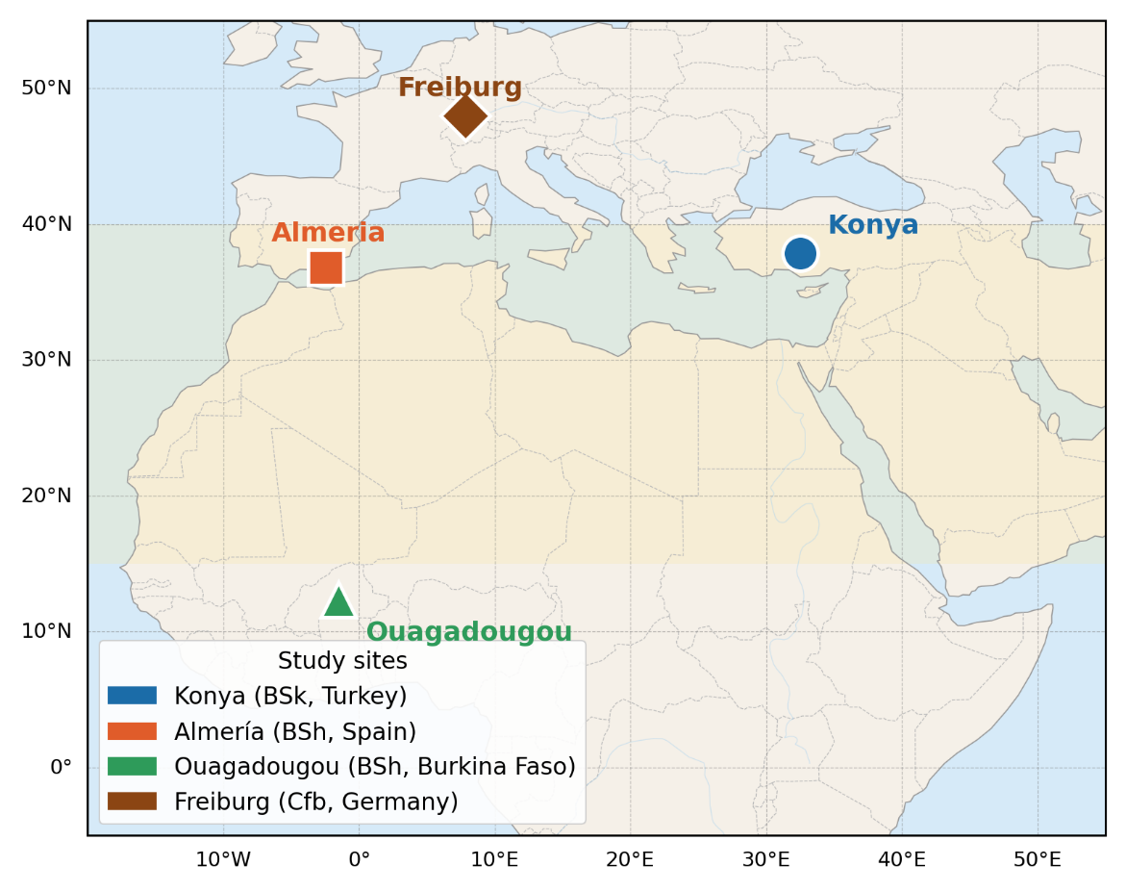
Figure 1 : Location map of the four study sites (Konya, Turkey; Almería, Spain; Ouagadougou, Burkina Faso; Freiburg, Germany) overlaid on the semi-arid belt of Europe, the Middle East and West Africa (BSk/BSh zones shaded in light yellow)

Their principal geographical and climatic characteristics are summarized in Table 4.

Table 4 : Geographical and climatic characteristics of the four study sites (PVGIS-SARAH3 TMY data).
Parameter | Konya (Turkey) | Almería (Spain) | Ouagadougou (BF) | Freiburg  (Germany)
Latitude | 37.87°N | 36.83°N | 12.37°N | 47.99°N
Longitude | 32.49°E | 2.46°W | 1.52°W | 7.85°E
Elevation (m a.s.l.) | 1,016 | 20 | 303 | 278
Köppen climate | BSk (cold semi-arid) | BSh (hot semi-arid) | BSh (tropical semi-arid) | Cfb (oceanic temperate)
Mean annual GHI (kWh/m²) | 1,650 | 1,850 | 2,050 | ~1,150
Mean annual $T (°C)$ | 11.5 | 18.5 | 28.5 | ~11.4
Summer $T_{\max\left(°C\right)}$ | 38 | 35 | 41 | ~35
Winter $T_{\min\left(°C\right)}$ | −10 | +5 | +15 | ~−12
Annual ET₀ (mm) | 1,200 | 1,350 | 1,800 | ~900
Annual precipitation (mm) | 320 | 200 | 800 | ~800
Irrigation requirement (mm) | 880 | 1,150 | 1,000 | ~400–500

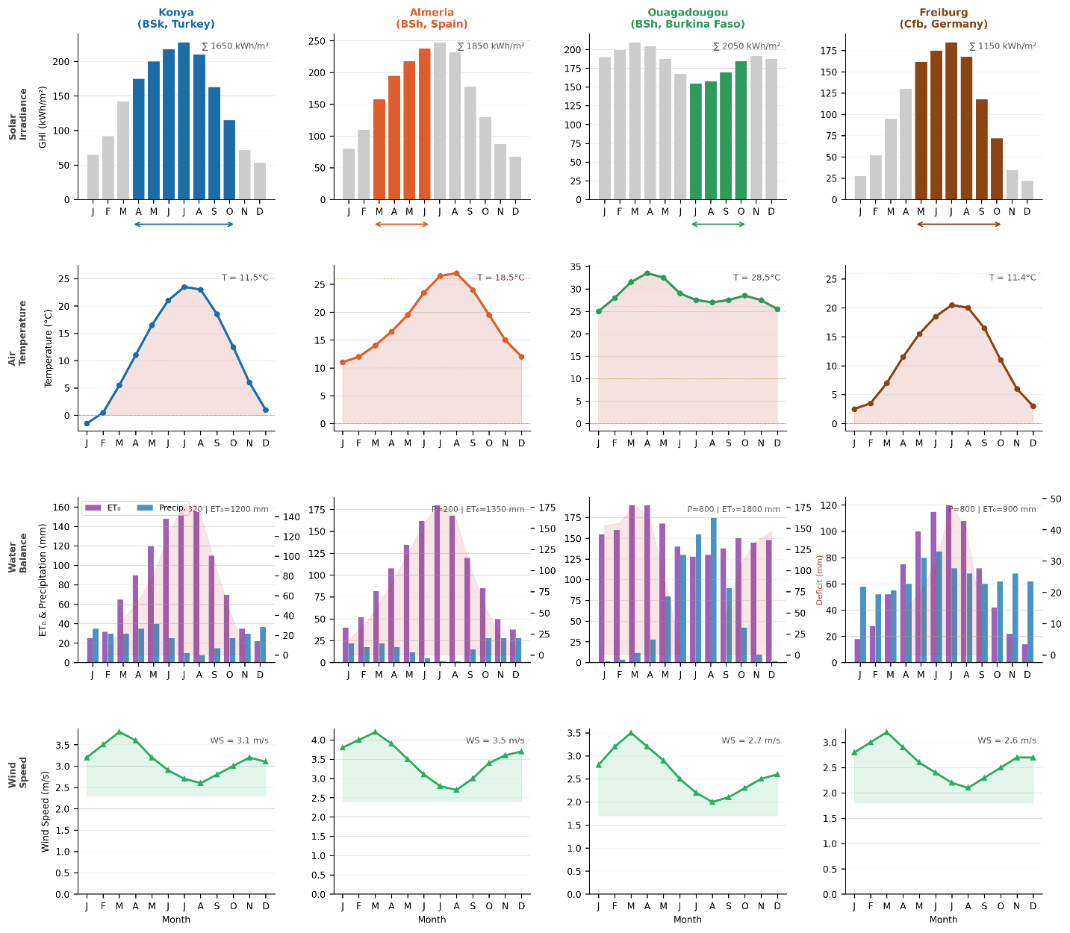
Figure 2 : Monthly climate profiles for the three sites: (a) GHI (kWh/m²), (b) mean air temperature (°C), (c) ET₀ vs precipitation (mm), and (d) wind speed (m/s). Horizontal bars indicate the tomato growing season.

Konya (37.87°N, 32.49°E, 1,016 m a.s.l.) is representative of the Central Anatolian Plateau, where a continental climate produces extreme seasonal swings: mean July temperatures around 23°C with maxima approaching 38°C give way to January means near −3°C with minima reaching −18°C or below. Annual GHI is approximately 1,650 kWh/m², and the persistent summer water deficit makes irrigation essential. These conditions maximize the solar resource for PV while presenting the most demanding thermal challenge for mesophilic AD: this is precisely the regime where PV-heat coupling has the greatest operational value.
Almería (36.83°N, 2.46°W, 22 m a.s.l.) sits on the Mediterranean coast of Andalusia and holds the distinction of being the driest location in continental Europe, with annual precipitation averaging just 200 mm against an ET₀ of 1,350 mm (Junta de Andalucía, 2022). The region hosts over 30,000 hectares under cultivation (Marín-Membrive et al., 2021). Unlike Konya, winter temperatures rarely fall below 5°C, substantially reducing heating energy demand. The growing season is truncated at the end of June to avoid the July–August heat period when daily maxima exceeding 35°C suppress tomato fruit set (Marín-Membrive et al., 2021).
Ouagadougou (12.37°N, 1.52°W, 303 m a.s.l.) lies in the Sahel and offers the highest solar resource of the four sites, with GHI averaging 2,050 kWh/m² annually. Winter minima remain above 13°C, meaning the digester operates near the mesophilic optimum for most of the year with minimal heating demand. The growing season (July 1–October 30) is timed to the wet monsoon to avoid the extreme pre-monsoon heat period. LPG displacement (Scenario S3) has particular relevance here: displacing LPG at its Sahelian market price of $0.18–0.22/kWh has both economic and energy-access significance (IEA Africa Energy Outlook, 2024).
Freiburg im Breisgau (47.99°N, 7.85°E, 278 m a.s.l.) is located in Baden-Württemberg, Germany, which hosts the highest density of agricultural biogas plants in Germany and the most developed agrivoltaic regulatory framework in Europe (§37 EEG 2023). The oceanic temperate (Cfb) climate has mild winters relative to Konya but with cold spells reaching −12°C, moderate summers with maxima around 35°C, and annual GHI of approximately 1,150 kWh/m² — the lowest of the four sites but the highest in Germany. Open-field tomato yield in Germany is 20–30 t/ha (DLG, 2023); the present study uses 30 t/ha (upper bound with drip irrigation), with the note that residue input (24 t/ha) is exactly half the semi-arid sites (48 t/ha), and all economic and eLER comparisons account for this structural difference.
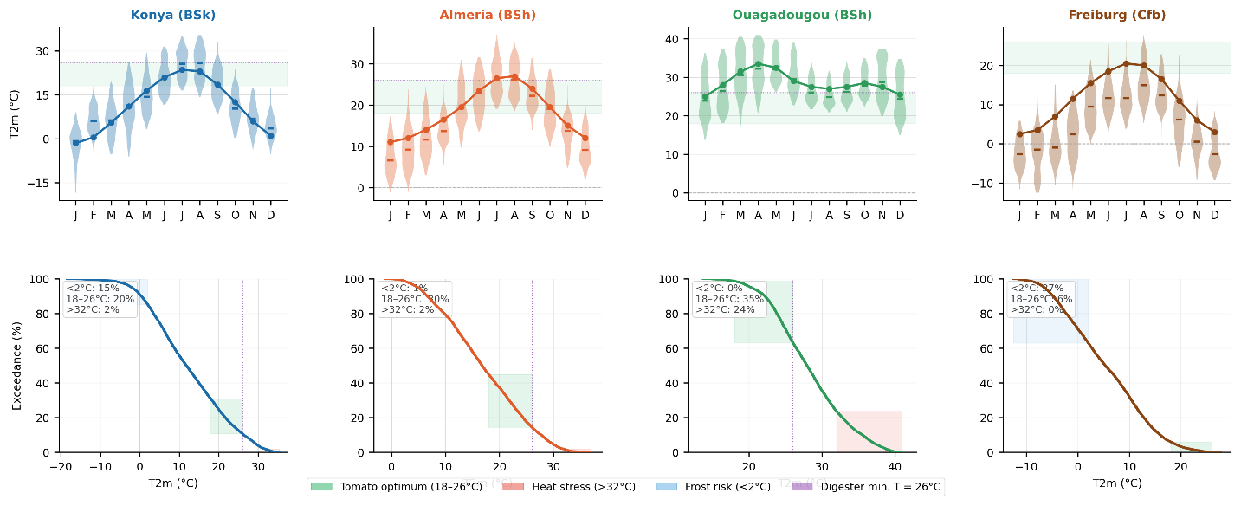
Figure 3 : Temperature characterization: (left) monthly distribution of 2‑m air temperature; (right) exceedance frequency curve. Colored bands indicate agronomic thresholds (optimal, heat stress, frost) and the minimum digester temperature (26 °C).
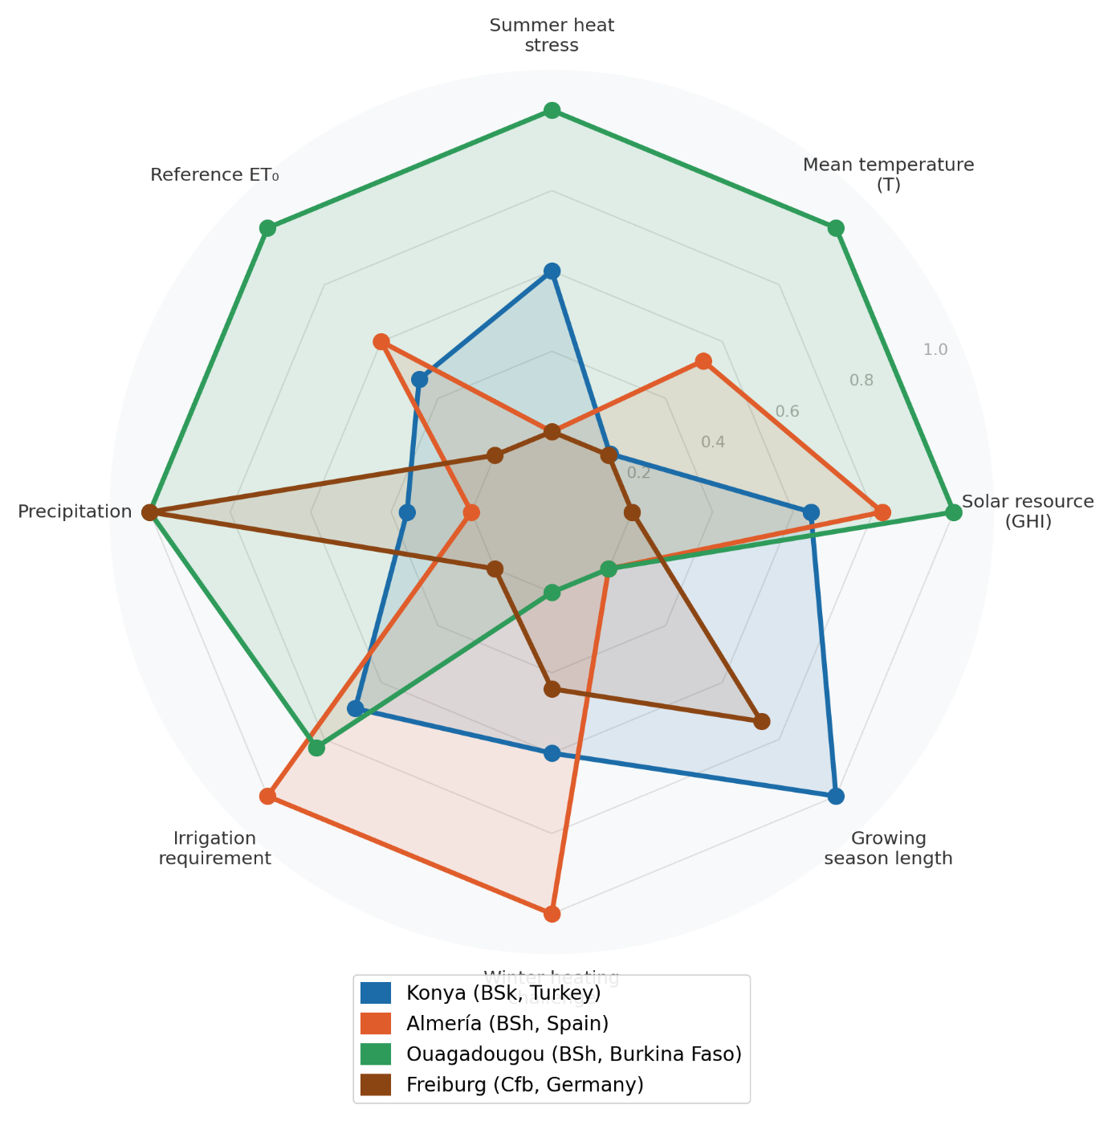
Figure 4 : Normalized radar chart comparing the three sites across eight climatic and agricultural dimensions (outer = higher value). This highlights the trade‑offs between solar resource, temperature extremes, water balance and growing season length.

3.2. Climate data acquisition and processing
Hourly TMY data for all four sites were extracted from the PVGIS-SARAH3 database maintained by the JRC (JRC, n.d.). PVGIS-SARAH3 was selected over ERA5 because its solar irradiance fields are derived from Meteosat Second Generation satellite observations, yielding mean bias errors below ±5% for monthly GHI across all four regions (Huld et al., 2012) (Huld et al., 2012; Urraca et al., 2017). The TMY files were processed to extract DNI and DHI columns directly, rather than estimating them from GHI using fixed beam-to-diffuse ratios — an improvement over simplified approaches that can introduce systematic errors under variable sky conditions. No data gaps exceeding one hour were encountered in any of the three downloaded files.
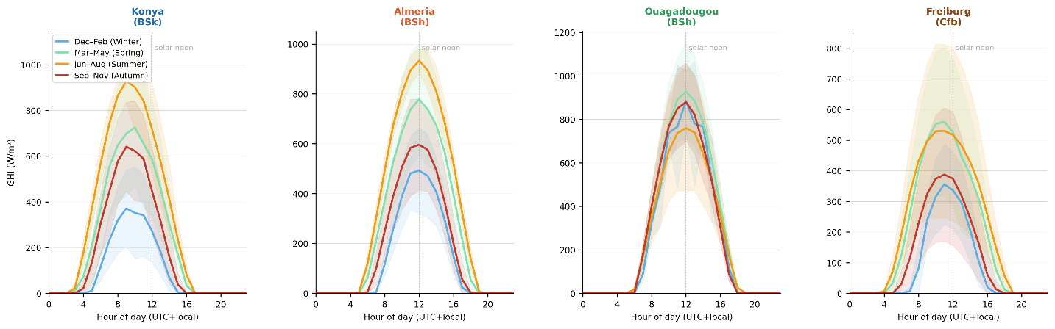
Figure 5 : Mean diurnal GHI profiles by season (DJF, MAM, JJA, SON) derived from PVGIS‑SARAH3 TMY data. Shaded bands represent ±1 standard deviation.

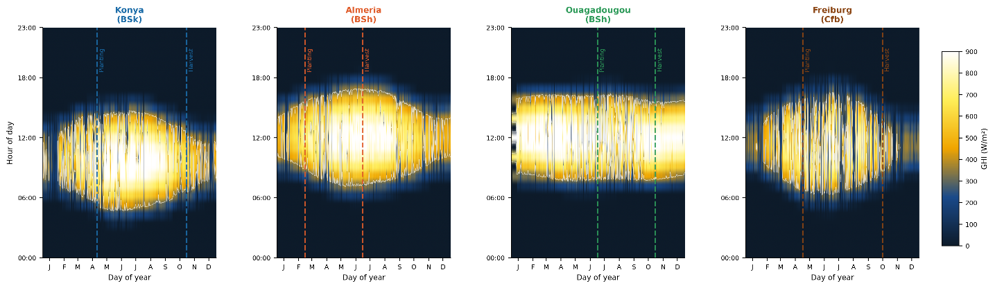
Figure 6 : Day‑of‑year × hour‑of‑day GHI heatmap (W/m²). White contour = 400 W/m² threshold; vertical dashed lines = start and end of the tomato growing season.

Site-specific tomato cultivation parameters are summarized in Table 5. Freiburg differs from the three semi-arid sites in yield (30 vs. 60 t/ha), growing season (May 1–October 15 vs. site-specific calendars), and electricity feed-in tariff (0.09 USD/kWh under EEG 2023). These differences are propagated through all economic calculations and eLER components.

Table 5 : Site-specific parameters for tomato (Solanum lycopersicum) cultivation.
Parameter | Konya | Almería | Ouagadougou | Freiburg
Planting date | 25 April | 1 March | 1 July | 1 May
Harvest date | 30 October | 30 June | 30 October | 15 October
Growing season (days) | 189 | 122 | 122 | 167
Fresh fruit yield (t/ha) | 60 | 60 | 60 | 30*
Ref. crop ET₀ (mm/season) | 650 | 480 | 620 | ~350
Irrigation efficiency | 0.75 | 0.85 | 0.70 | 0.80
Tomato price (USD/t) | 300 | 400 | 250 | 350
Electricity price (USD/kWh) | 0.06 | 0.09 | 0.12 | 0.09
Discount rate (%) | 8 | 6 | 10 | 5
Primary growing constraint | Spring frost | Summer heat | Pre-monsoon heat | Spring frost
* Open-field German yield with drip irrigation, upper bound (DLG, 2023). Residue input = 24 t/ha vs. 48 t/ha at semi-arid sites; VS input = 4,080 vs. 8,160 kg VS/ha/year.

3.3. Solar geometry and shading model
Accurate hourly solar position calculation forms the foundation for both the PV transposition model and the ground shading factor. Solar declination δ is computed using the Spencer (1971) harmonic approximation:

$$\begin{aligned}δ=23.45°×sin\left[\frac{360°}{365}×\left(n-81\right)\right]\#\left(3\right)\end{aligned}$$

where n is the day of year. True solar time is obtained from local standard time by applying both a longitude correction for the offset from the standard meridian and the Equation of Time $EoT(n)$, which accounts for the eccentricity of Earth's orbit and the obliquity of the ecliptic (Spencer, 1971):

$$\begin{aligned}t_{solar}= t_{local}+\frac{\left(L - L_{std}\right)}{15} +\frac{EoT\left(n\right)}{60} \#\left(5\right)\end{aligned}$$

The solar hour angle ω follows directly, equaling zero at solar noon. Solar elevation angle $α_{s}$ and azimuth $γ_{s}$ are then computed from standard spherical trigonometric relations. The ground shading factor $F_{shad}\left(t\right)$, which quantifies the fraction of land area receiving direct shadow from the panel rows at each hour, is computed following Zainali et al. (Zainali et al., 2023), who validated this formulation against direct measurements across six agrivoltaic layouts:

$$\begin{aligned}F_{shad\left(t\right)}=\min\left(1,\frac{ H_{m}×\cos\left(Δγ\right)}{row_{spacing}×\tan\left(α_{s}\right)}\right)\#\left(6\right)\end{aligned}$$

where $H_{m}$ is the module bottom-edge height above ground in meters, $Δγ$ is the azimuth difference between the sun's direction and the row orientation, and $d_{row}$ is the row pitch in meters. The expression is clipped to a maximum of 1.0 to prevent non-physical values at very low solar elevation angles near sunrise and sunset.

3.4. Photovoltaic energy model

3.4.1. Plane-of-array irradiance
This study uses the direct DNI and DHI columns from the PVGIS-SARAH2 files. Plane-of-array irradiance is decomposed into three components following the isotropic sky model of Liu and Jordan (1960) :

$$\begin{aligned}G_{front}= DNI ×\cos\left(θ_{i}\right)+ DHI ×\frac{1 + cosβ}{2}+ GHI × ρ_{g}×\frac{1 - cosβ}{2}\#\left(7\right)\end{aligned}$$
where $θ_{i}$ is the angle of incidence on the tilted panel surface, $β$ is the tilt angle, and $ρ_{g}= 0.25$ is the ground albedo for agricultural soil (Monteith & Unsworth, 2008). For bifacial modules (Bifaciality factor $ϕ = 0.70$), the rear surface receives diffuse sky radiation on its underside plus ground-reflected radiation. The effective plane-of-array irradiance combining both sides is:

$$\begin{aligned}G_{eff}= G_{front}+ ϕ × G_{rear}× \left(1 - η_{loss}\right)\#\left(8\right)\end{aligned}$$

3.4.2. Cell temperature and power output
Cell operating temperature is modelled using the Faiman (2008) approach, which is more appropriate for dynamic hourly simulation than the Nominal Operating Cell Temperature (NOCT) method because it explicitly accounts for wind-dependent convective cooling:

$$\begin{aligned}T_{cell\left(t\right)}= T_{amb\left(t\right)}+\frac{G_{eff\left(t\right)}}{\left(U_{0}+ U_{1}× u\left(t\right)\right)} \#\left(9\right)\end{aligned}$$
where U₀ = 25 W/m²·K is the constant thermal loss coefficient and U₁ = 6.84 W·s/m³·K is the wind-dependent coefficient, both from Faiman (Faiman, 2008). Module power output $P_{PV}$ in watts at each timestep is then:

$$\begin{aligned}P_{PV\left(t\right)}= P_{STC}× N × \left(1-η_{loss}\right)×\left[1 + β_{p}\left(T_{cell\left(t\right)}- 25\right)\right]×\frac{G_{eff\left(t\right)}}{1000} \#\left(10\right)\end{aligned}$$

where $N$ is the number of modules, $P_{STC}= 550 W_{p}$ is the rated power under standard test conditions (Jinko Tiger Neo N-type bifacial datasheet), $η_{loss}= 0.12$ aggregates wiring, inverter, and mismatch losses consistent with field measurements from comparable bifacial utility-scale installations (Jordan & Kurtz, 2013), and $β_{p}= -0.0035 °C^{-1}$ is the temperature power coefficient from the module datasheet.

3.5. Crop yield model
Relative crop yield $\frac{Y_{crop}}{Y_{ref}}$ is estimated from the seasonal integral of photosynthetically active radiation (PAR) reaching the crop canopy under the APV panels, normalized to the corresponding open-field PAR integral. PAR is estimated as 48% of GHI following McCree (McCree, 1971) and the subsequent empirical calibration by Jacovides et al. (Jacovides et al., 2006), who confirmed that the PAR/GHI ratio for agricultural sites under mixed sky conditions falls in the range 0.45–0.50, with 0.48 as the central estimate.
A crop-specific PAR saturation threshold is applied: when incident PAR exceeds the light saturation point, additional photons produce no incremental photosynthesis. For tomato (Solanum lycopersicum), the light saturation point is approximately 800 μmol/m²/s ≈ 174 W/m² (Mohammedi et al., 2023; Heuvelink, 2005), which is substantially higher than the 76 W/m² appropriate for shade-tolerant species such as lettuce or spinach. Using the correct species-specific threshold is methodologically critical: an erroneously low threshold inflates the simulated crop yield ratio to unity regardless of shading, masking the actual trade-off between panel coverage and crop productivity.
The hourly PAR integral over the growing season yields the annual yield ratio:

$$\begin{aligned}\frac{Y_{crop}}{Y_{ref}}=\frac{\int_{t_{0}}^{t_{1}}{\min\left(PAR_{AV}\left(t\right),PAR_{sat}\right)dt}}{\int_{t_{0}}^{t_{1}}{PAR_{open}\left(t\right)dt}}\#\left(11\right)\end{aligned}$$

where $PAR_{AV}\left(t\right)=GHI(t)×0.48×(1-F_{shad}(t)$ is the PAR reaching the crop canopy under panels, $PAR_{open}\left(t\right)=GHI\left(t\right)×0.48$ is open-field PAR, $PAR_{sat}=174 W/m^{2}$ is the tomato-specific saturation threshold $F_{shad}\left(t\right)$is the hourly shading factor (Eq. 6), and $t_{0}$and $t_{1}$ are the site-specific season start.

3.6. Evapotranspiration reduction under APV panels
Reference ET₀ is calculated hourly using the FAO-56 Penman-Monteith equation (Allen et al., n.d.) with site-specific psychrometric constants γ adjusted for elevation. ET_APV(t) = ET₀(t) × (1 − α_shade × F_shad(t)) (Eq. 14), where α_shade = 0.40 (Tawassulli, 2025; Elamri et al., 2018). Annual water savings W_saved = Σ[ET₀(t) − ET_APV(t)] are computed over the growing season only.
The analytical ET reduction under eLER-optimal design can be derived as: ΔET/ET₀ ≈ α_shade × GCR × k_solar = 0.40 × 0.545 × 0.40 ≈ 8.7% of seasonal ET₀. However, the simulation denominator is the full annual ET₀ (not just the growing season), explaining the lower reported fractions of 1.5–2.7%. The gap between 8.7% (seasonal) and 15–35% reported in the literature is explained by the lower GCR of the eLER-optimal design and the absence of soil-moisture retention feedback in the present model.

3.7. Anaerobic digestion model

3.7.1. Feedstock characterization
At the three semi-arid sites, with fresh fruit yield of 60 t/ha and residue-to-fruit ratio of 0.80 (Mohammedi et al., 2023), annual VS input is 8,160 kg VS/ha. At Freiburg (30 t/ha), VS input is 4,080 kg VS/ha — exactly half. $BMP_{ref} = 300 NmL CH₄/g VS$ (Feng et al., 2013; Lallement et al., 2023).

3.7.2. Temperature-corrected methane yield
Effective digester temperature $T_{dig,eff}$ follows a seasonal management strategy informed by Lindorfer et al. (Lindorfer et al., 2008): the digester is actively heated to a minimum of 26°C in winter and spring, and allowed to approach the mesophilic optimum of 37°C in summer and autumn when solar energy is abundant:

$$\begin{aligned}T_{dig,eff}= clip\left(T_{amb}+ 5, 26°C, 37°C\right)\#\left(16\right)\end{aligned}$$
The temperature-corrected BMP is then given by the Arrhenius relationship validated by Pilarski and Pilarska (Pilarski & Pilarska, 2025) and Lindorfer et al. (Lindorfer et al., 2008):

$$\begin{aligned}BMP\left(T_{dig,eff}\right)= BMP_{ref}×\exp\left[θ × \left(T_{dig,eff}- 37\right)\right]\#\left(17\right)\end{aligned}$$

where $θ = 0.069 °C⁻¹$. The monthly BMP correction is computed from monthly mean ambient temperatures drawn from the PVGIS-SARAH2 TMY dataset, introducing a physically grounded, site-specific coupling between the local climate and biogas subsystem performance.

3.7.3. Digester heat balance
Daily heat demand Q_heat = Q_loss,cond + Q_inflow − Q_reaction (Eq. 18), where Q_loss,cond = U_eff × A_wall × (T_dig,eff − T_amb) × 24/1000 and Q_reaction = 5% of daily biogas energy (Pal & Ilango, 2024). The PV system supplies fraction f_PV,heat × E_PV as electrical resistance heating (η_elec = 0.95). Any remaining deficit is met by biogas combustion (η_bio = 0.85). Configurations where biogas cannot cover the remaining deficit are declared infeasible.

3.7.4. Scope of LER_biogas
LER_biogas = E_biogas,net / E_biogas,ref, where E_biogas,ref is thermally unconstrained production at 37°C. When ESR = (E_PV + E_biogas) / Q_heat substantially exceeds the threshold 1/f_PV,heat ≈ 6, PV fully covers digester heat demand and LER_biogas = 1.000 by construction. This is a design validation criterion confirming thermal self-sufficiency — not an empirically discovered finding. At Freiburg, lower GHI and higher heat demand produce the lowest ESR (76.3), providing the tightest test of this criterion.

3.8. Extended Land Equivalent Ratio formulation
The eLER adds net biogas energy as a third land-use output: eLER = Y_crop,AV/Y_crop,open + E_PV,net/E_PV,ref + E_biogas,net/E_biogas,ref (Eq. 22). The PV reference uses an independent open-field dense-pack simulation at the same tilt (Definition A), avoiding the circular definition used in prior studies. For literature comparability, the circular reference (Definition B: LER_PV_B ≈ GCR) is also reported. eLER > 1 indicates that the integrated APV-AD system produces more combined output per unit land area than the best-performing monoculture reference for each component in isolation. LER_2C = LER_crop + LER_PV is reported alongside eLER for direct comparison with the published agrivoltaic literature.

3.9. Multi-variable design optimization
The integrated system is optimized over six continuous design variables (Table 7) using differential evolution (Storn & Price, 1997). Objective: maximize eLER subject to $20 ≤ HRT ≤ 40 d$ and $1.5 ≤ OLR ≤ 5.0 kg VS/m³·d$. DE settings: population $size = 15 × n_{var}= 90$; mutation $F ∈ [0.5, 1.0]$; crossover $C_{r}= 0.7$; 50 generations; L-BFGS-B polishing; seed = 42. For the multi-objective Pareto analysis (R3-B), NSGA-II (pymoo; Blank & Deb, 2020) is used with 50 solutions and 80 generations, maximizing $eLER_{global}$ and $LER_{water}$ simultaneously.
The bi-objective Pareto optimization produces a well-populated front at Konya (189-day season) but degenerate results at Almería (122 d), Ouagadougou (122 d), and Freiburg (167 d). Degenerate fronts arise because $LER_{water}$ variation across the design space falls below numerical resolution at the eLER-optimal GCR ≈ 54.5%: at 122 days with $ET_{0_{season}}≈ 480–620 mm$, cumulative water saving variation is of order 10⁻¹² mm. Only the Konya front — with 189 days, $ET_{0_{season}}≈ 650 mm$, and sufficient variation to populate 50 Pareto solutions — is reported in the results.

Table 7. Design variable bounds for the differential evolution optimization.
Table 6 : Design variable bounds for the differential evolution optimization.
Variable | Symbol | Lower bound | Upper bound | Unit
Panel tilt angle | $$β$$ | 10 | 40 | °
Row spacing | $$d_{row}$$ | 4 | 14 | m
Module bottom-edge height | $$H_{m}$$ | 2 | 5 | m
Digester volume | $$V_{dig}$$ | 50 | 300 | m³
Hydraulic retention time | $$HRT$$ | 20 | 40 | days
PV heating fraction | $$f_{PV,heat}$$ | 0.05 | 0.50 | —

3.10. AD scenario analysis
Six AD valorization scenarios are analyzed at all four sites (Table 7). Scenario S5 (biomethane upgrading) is introduced based on the Italian market premium of Nik Zad et al. (2026) (5.5× electricity purchase price) and the German EEG 2023 feed-in framework. At Freiburg ($p_{elec} = 0.09 USD/kWh$), biomethane is valued at 0.495 USD/kWh — consistent with published European biomethane gate prices of 0.40–0.55 EUR/kWh (EBA, 2025; Rabobank, 2025).

Table 7 : AD valorization scenarios.
Scenario | Description | Key modification
S0 | Baseline (mono-digestion, 100% grid export) | BMP_mult = 1.00, η_cap = 1.00
S1 | Co-digestion (30% cattle manure, +15% BMP) | BMP_mult = 1.15
S2 | Sub-optimal (85% CH₄ capture) | η_cap = 0.85
S3 | Local LPG displacement (on-site use at LPG parity) | p_biogas = $0.18/kWh
S4 | Digestate valorization (N-P-K credit) | N credit at $1.20/kg N
S5 | Biomethane grid injection (5.5× electricity price for Italian Market) | p_biogas = 5.5 × p_elec; after Nik Zad et al. (2026); EEG 2023

3.11. Summary of model parameters
All fixed model parameters are compiled in Table 8.

Table 8 : Fixed model parameters.
Parameter | Symbol | Value | Unit | Source
Module rated power | $$P_{STC}$$ | 550 | $$W_{p}$$ | Jinko Tiger Neo datasheet
Bifaciality factor | $$ϕ$$ | 0.70 | — | Jinko Tiger Neo datasheet
Temperature coefficient | $$β_{p}$$ | −0.0035 | K⁻¹ | Jinko Tiger Neo datasheet
System losses | $$η_{loss}$$ | 0.12 | — | Jordan & Kurtz (2013)
Faiman U₀ | U₀ | 25 | W/m²·K | Faiman (2008)
Faiman U₁ | U₁ | 6.84 | W·s/m³·K | Faiman (2008)
Ground albedo | $$ρ_{g}$$ | 0.25 | — | Monteith & Unsworth (2008)
PAR fraction of GHI | $$f_{PAR}$$ | 0.48 | — | McCree (1971)
Tomato PAR saturation | $$PAR_{sat}$$ | 174 | W/m² | Mohammedi et al. (2023)
ET shading coefficient | $$α_{shade}$$ | 0.40 | — | Tawassulli (2025)
Tomato DM fraction | $$DM$$ | 0.20 | kg/kg | Mohammedi et al. (2023)
Volatile solids fraction | $$VS$$ | 0.85 | kg/kg DM | Lallement et al. (2023)
Reference BMP at 37°C | $$BMP_{ref}$$ | 300 | NmL/g VS | Lallement et al. (2023)
Arrhenius coefficient | $$θ$$ | 0.069 | °C⁻¹ | Pilarski & Pilarska (2025)
Digester thermal transmittance | $$U_{eff}$$ | 0.8 | W/m²·K | Lindorfer et al. (2008)
Substrate heat capacity | $$C_{p}$$ | 4.18 | kJ/kg·K | Water approximation
Electrical heating efficiency | $$η_{elec}$$ | 0.95 | — | Pal & Ilango (2024)
Biogas CHP heating efficiency | $$η_{bio}$$ | 0.85 | — | Temiz et al. (n.d.)
Methane LHV | $$LHV_{CH_{4}}$$ | 35.8 | MJ/m³ | Marchaim (1992)
Residue/fruit ratio | $$R_{res}$$ | 0.80 | — | Mohammedi et al. (2023)

4. Results

4.1. Optimization convergence and optimal design parameters
The differential evolution optimizer converged to feasible solutions within 50 generations at all four sites. Table 10 reports the optimal design variables and the principal performance outcomes derived from the CSV simulation output.

Table 10. Optimal design parameters and primary performance metrics for all four sites.
Table 9 : Optimal design parameters and primary performance metrics for all four sites.
Parameter | Konya | Almería | Ouagadougou | Freiburg
Tilt angle $β \left(°\right)$ | 33.3 | 19.3 | 26.0 | 15.9
Row spacing $d_{row}\left(m\right)$ | 4.00 | 4.00 | 4.00 | 4.00
Module height $H_{m}\left(m\right)$ | 2.02 | 3.03 | 2.48 | 2.69
Digester volume $V_{dig}\left(m^{3}\right)$ | 64 | 80 | 114 | 53
HRT design (days) | 29.1 | 21.8 | 22.8 | 20.8
PV heating fraction $f_{PV,heat}$ | 0.050 | 0.050 | 0.050 | 0.050
$$n_{modules}$$ | 2,110 | 2,111 | 2,111 | 2,111
GCR (%) | 54.5 | 54.5 | 54.5 | 54.5
HRT actual (days) | 39.1 | 36.4 | 54.3 | 45.9
OLR (kg VS/m³·d) | 4.35 | 4.67 | 3.13 | 3.70

The optimizer converges to the minimum permissible row spacing of 4.0 m (lower bound) at all four sites, confirming that maximum module density is consistently preferred under the eLER objective. This result is physically interpretable: more modules increase absolute PV output; since the $LER_{PV}$ reference is computed at the same tilt and scales proportionally with GHI, $LER_{PV}(A)$ remains approximately constant with GCR, and the optimization instead exploits the $LER_crop$ sensitivity to shading. Tilt angles diverge from the energy-maximizing rule of thumb (latitude − 10° to latitude + 5°) because lower tilt minimizes inter-row shadow projection during the growing season, directly increasing $LER_crop$ with minimal effect on $LER_{PV}(A)$ . The PV heating fraction $f_{PV,heat} = 0.05$ at all sites reflects the minimum required: at this fraction, PV delivers 3.6–7.8× the heat demand, so further allocation would simply reduce PV grid export without thermal benefit. The eLER sensitivity to row spacing is quantified by the R3-A access sweep (Section 4.6 and Figure 7).
Supplementary Figure S1 shows the geographic locations of all four sites. Supplementary Figures S2–S8 provide detailed climate profiles, diurnal GHI patterns, temperature frequency analyses, GHI heatmaps, multi-variable radar comparisons, growing season calendars, and a summary statistics table for all four sites including Freiburg.

4.2. Extended Land Equivalent Ratio decomposition
Table 10 presents the complete eLER decomposition for all four sites under the Baseline scenario (S0). Figure 2 displays these results as a stacked bar chart comparing both $LER_{PV}$ definitions.
Table 10 : eLER decomposition for all four sites (Scenario S0, Baseline).
Metric | Konya  (BSk) | Almería (BSh) | Ouagadougou (BSh) | Freiburg  (Cfb)
$$LER_{crop}$$ | 0.670 | 1.000 | 1.000 | 0.739
$LER_{PV}$ (Def. A, independent) | 0.293 | 0.293 | 0.293 | 0.293
$LER_{PV}$ (Def. B, circular = GCR) | 0.545 | 0.545 | 0.545 | 0.545
$$LER_{biogas}$$ | 1.000 | 1.000 | 1.000 | 1.000
$eLER_{global}$ (Def. A) | 1.963 | 2.293 | 2.293 | 2.032
$eLER_{global}$ (Def. B) | 2.215 | 2.545 | 2.545 | 2.285
$$LER_2C = LER_{crop} + LER_{PV}(A)$$ | 0.963 | 1.293 | 1.293 | 1.032
Lit. max LER_2C (Riaz et al. 2022) | 1.94 | 1.94 | 1.94 | 1.94

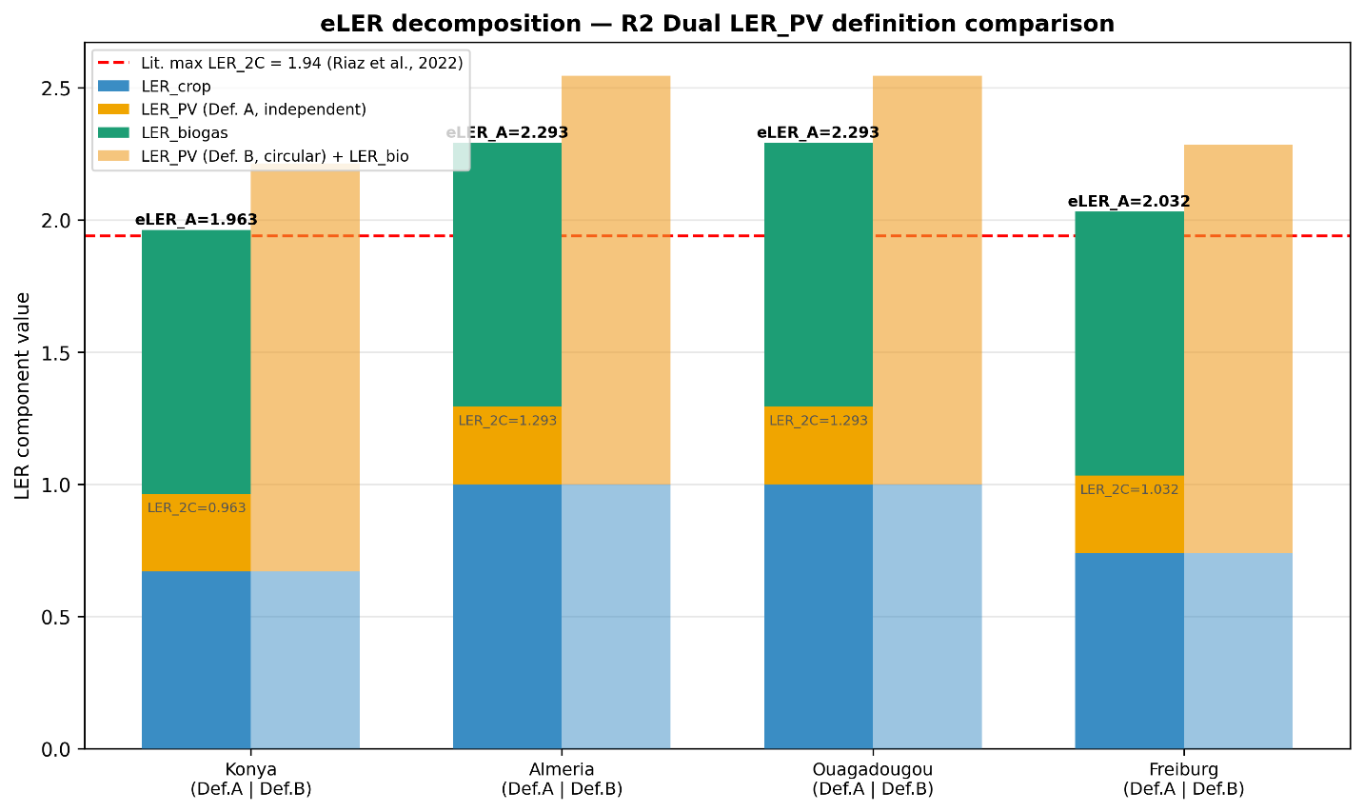
[FIGURE: Fig2_eLER_decomposition.png — eLER decomposition, dual LER_PV definitions, all four sites]
Figure 2. eLER decomposition for all four study sites under Scenario S0. Left bars (solid colors) decompose eLER under the independent reference (Definition A): blue = LER_crop, orange = LER_PV_A, green = LER_biogas. Right bars (faded) show the circular reference alternative (Definition B). The red dashed line marks the published maximum two-component LER of 1.94 (Riaz et al., 2022). All four sites exceed this benchmark under eLER_global (Definition A).

Three findings stand out from Figure 2 and Table 11. First, $eLER_{global}$ under Definition A exceeds 1.94 at all four sites (range: 1.963–2.293), while LER_2C at all sites remains below 1.94 (range: 0.963–1.293). The biogas component ($LER_{biogas}= 1.000$) is the sole driver that pushes every site above the literature benchmark. This confirms the central argument for the eLER metric: waste valorization through AD generates land-use efficiency comparable to or exceeding the entire agrivoltaic benefit, yet it is invisible to the conventional two-component LER.
Second, $LER_crop = 1.000$ at Almería and Ouagadougou. At Almería, the growing season runs March–June, when solar elevation at 37°N is already high (53°–77° at noon). With $H_{mod}= 3.03 m$ and $d_{row}= 4.0 m$, the GHI-weighted mean shading fraction across daylight hours during this period is approximately 0.02–0.05 — too small to measurably reduce the seasonal PAR integral. Additionally, mean daytime GHI during March–June at Almería is approximately 280 W/m², giving $PAR_{open} = 134 W/m²$, which is below the tomato saturation threshold of 174 W/m², so the asymmetric FIX 1 denominator is never clipped. At Ouagadougou, the growing season runs July–October at latitude 12.4°N, where the sun passes near zenith (solar elevation 75°–90° at noon) and $F_{shad}≈ 0$ geometrically. Both $LER_{crop}= 1.000$ values are therefore physically correct and imply that the eLER-optimal panel configuration delivers full PV generation at no measurable crop yield cost at these two sites — a strong argument for APV adoption in Mediterranean and tropical agricultural contexts.
Third, LER_PV_A = 0.293 at all four sites, despite GHI varying by a factor of 1.8 from Freiburg to Ouagadougou. This uniformity reflects the optimizer's convergence to d_row = 4.0 m at every site: GCR = 54.5% everywhere, and since LER_PV_A = E_PV,net / E_PV,ref and both numerator and denominator scale proportionally with GHI (the reference is computed at the same site and tilt), LER_PV_A is approximately GCR-determined rather than irradiance-determined.

4.3. Energy performance and seasonal dynamics
Table 12 summarizes annual energy performance. Figures 1a–d present the monthly energy balance for each site (PV allocation between grid export and digester heating, upper panel; monthly biogas energy and BMP seasonal arc, lower panel).

Table 12. Annual energy performance and thermal balance for all four sites.
Table 11 : Annual energy performance and thermal balance for all four sites.
Parameter | Konya | Almería | Ouagadougou | Freiburg
Annual PV total (MWh/ha) | 1,735 | 2,227 | 2,382 | 1,560
Annual PV sold to grid (MWh/ha) | 1,649 | 2,116 | 2,263 | 1,482
Annual biogas total (MWh/ha) | 15.5 | 17.8 | 24.3 | 6.0
Annual biogas sold (MWh/ha) | 15.5 | 17.8 | 24.3 | 6.0
Annual heat demand (MWh/ha) | 21.7 | 23.3 | 14.5 | 20.5
Biogas used for heating (MWh) | 0.0 | 0.0 | 0.0 | 0.0
ESR | 80.8 | 96.2 | 165.6 | 76.3
BMP annual average (NmL CH₄/g VS) | 190.7 | 218.8 | 300.0 | 148.8
BMP_winter (January, NmL/gVS) | ~140 | ~140 | 300 | ~140
BMP_summer (July, NmL/gVS) | ~300 | ~300 | 300 | ~155

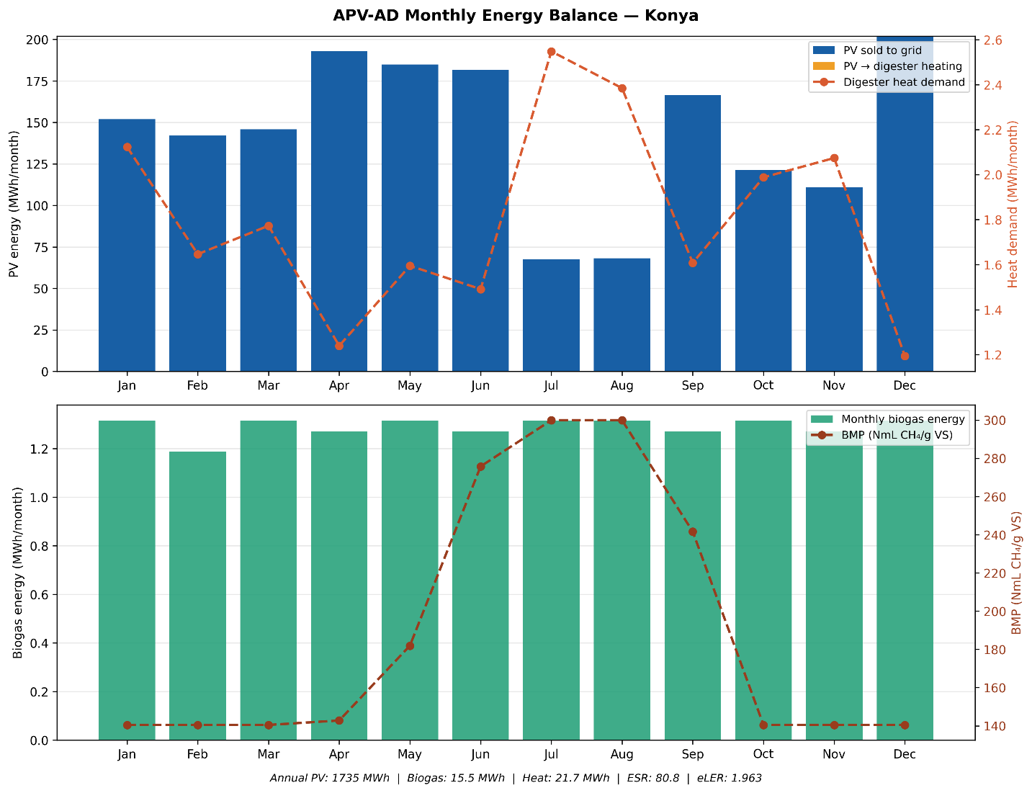
[FIGURE: Fig1_energy_balance_Konya.png — APV-AD Monthly Energy Balance — Konya]
Figure 1a. Monthly energy balance at Konya. Upper panel: PV energy (MWh/month) partitioned between grid export (blue bars) and digester heating (orange bars), with digester heat demand shown on the right axis (dashed orange line). Lower panel: monthly biogas energy (green bars) and BMP seasonal arc (brown dashed line, right axis). Summary statistics (annual PV, biogas, heat demand, ESR, eLER) appear in the figure annotation.
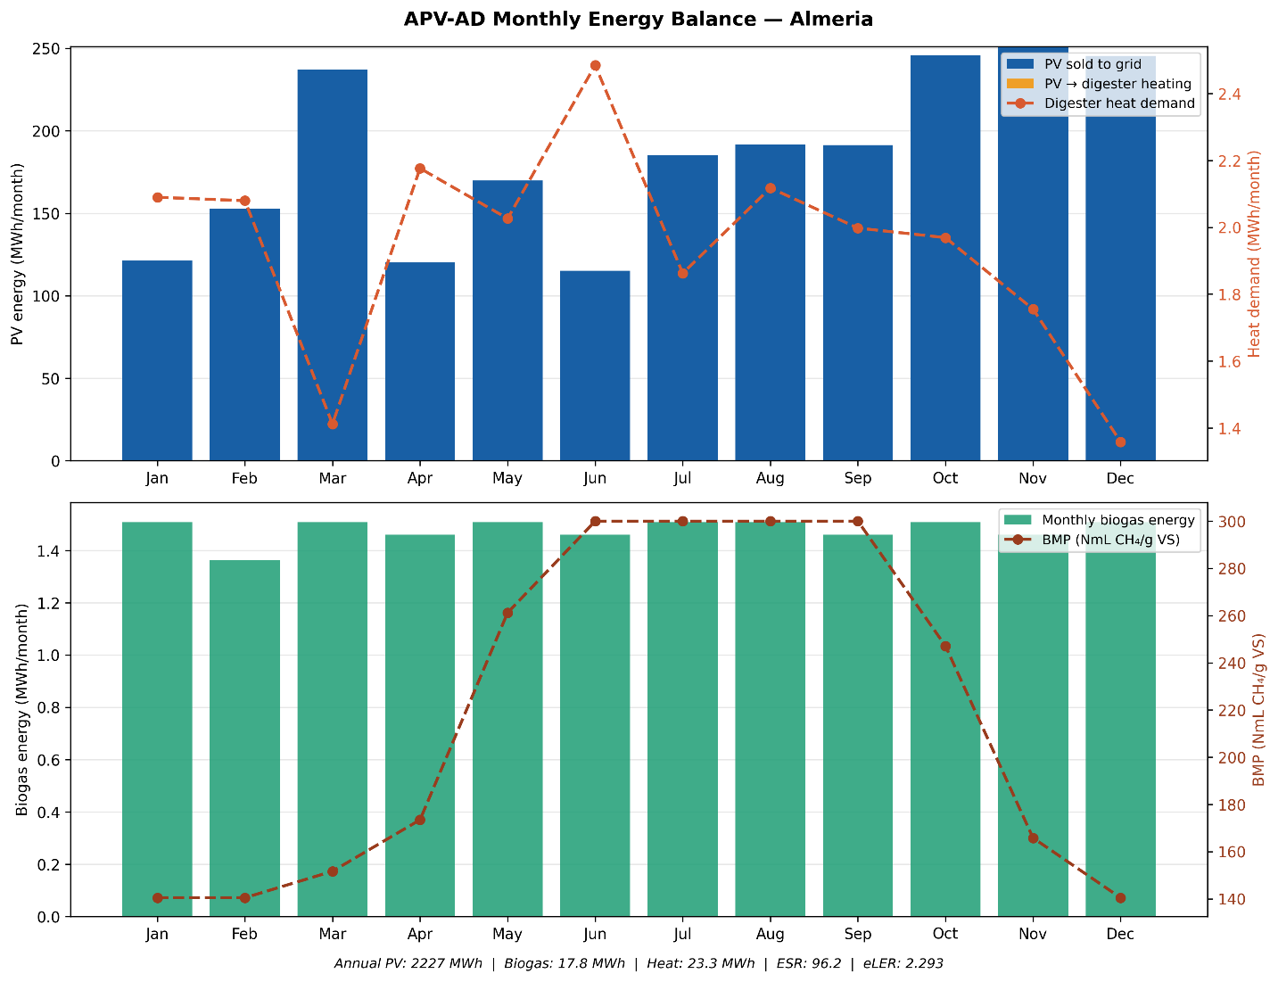
[FIGURE: Fig1_energy_balance_Almeria.png — APV-AD Monthly Energy Balance — Almería]
Figure 1b. Monthly energy balance at Almería. Upper panel: PV energy (MWh/month) partitioned between grid export (blue bars) and digester heating (orange bars), with digester heat demand shown on the right axis (dashed orange line). Lower panel: monthly biogas energy (green bars) and BMP seasonal arc (brown dashed line, right axis). Summary statistics (annual PV, biogas, heat demand, ESR, eLER) appear in the figure annotation.
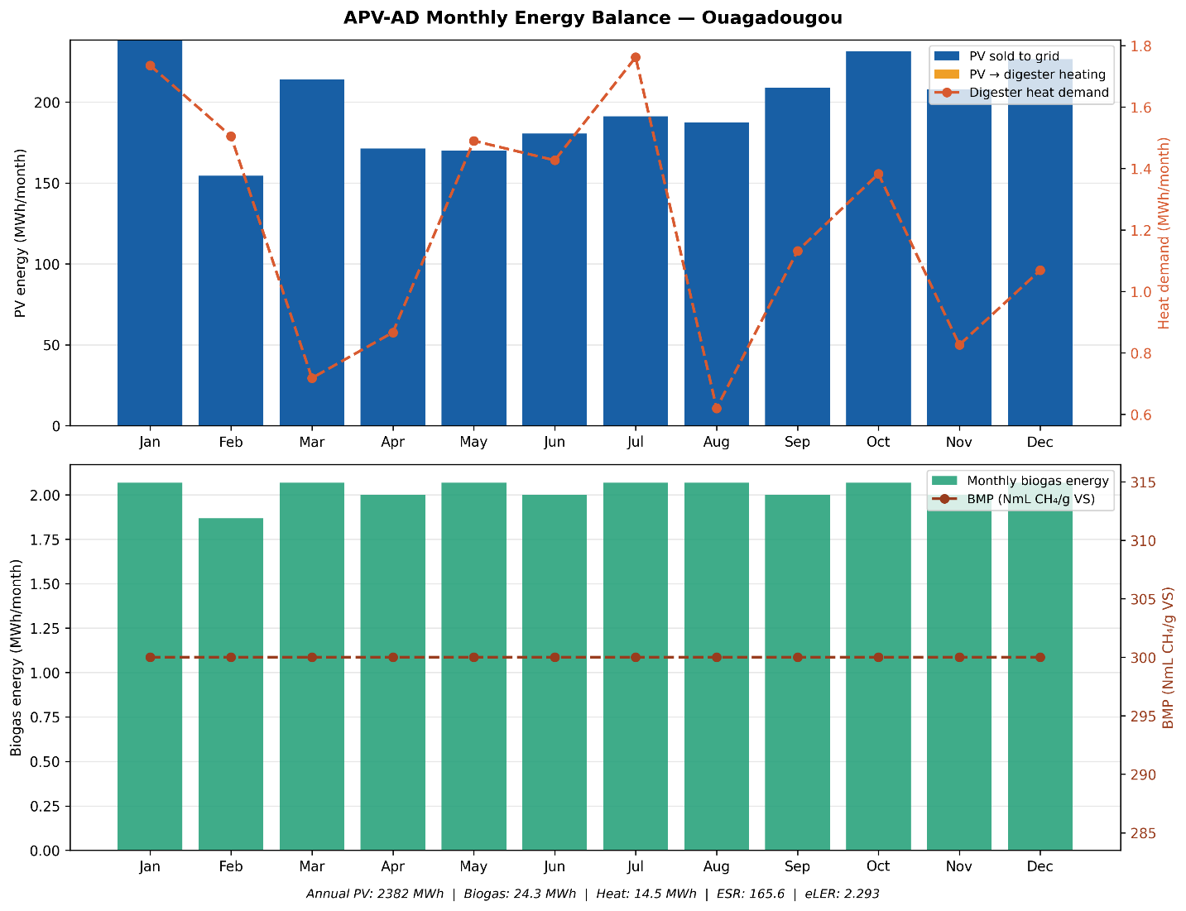
[FIGURE: Fig1_energy_balance_Ouagadougou.png — APV-AD Monthly Energy Balance — Ouagadougou]
Figure 1c. Monthly energy balance at Ouagadougou. Upper panel: PV energy (MWh/month) partitioned between grid export (blue bars) and digester heating (orange bars), with digester heat demand shown on the right axis (dashed orange line). Lower panel: monthly biogas energy (green bars) and BMP seasonal arc (brown dashed line, right axis). Summary statistics (annual PV, biogas, heat demand, ESR, eLER) appear in the figure annotation.
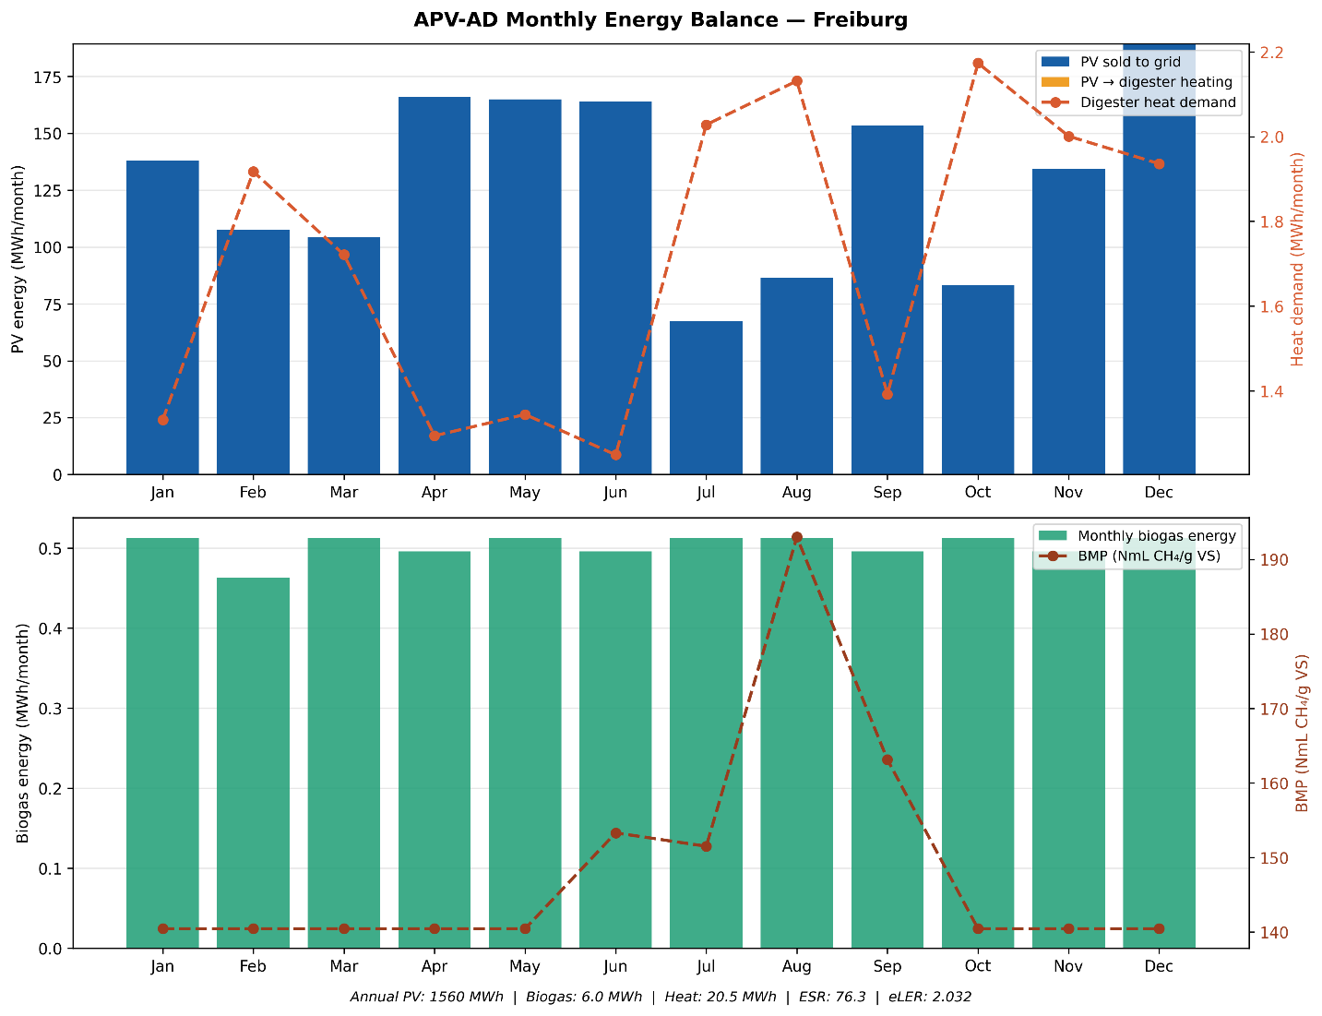
[FIGURE: Fig1_energy_balance_Freiburg.png — APV-AD Monthly Energy Balance — Freiburg]
Figure 1d. Monthly energy balance at Freiburg. Upper panel: PV energy (MWh/month) partitioned between grid export (blue bars) and digester heating (orange bars), with digester heat demand shown on the right axis (dashed orange line). Lower panel: monthly biogas energy (green bars) and BMP seasonal arc (brown dashed line, right axis). Summary statistics (annual PV, biogas, heat demand, ESR, eLER) appear in the figure annotation.

ESR ranges from 76.3 (Freiburg) to 165.6 (Ouagadougou), confirming thermal self-sufficiency at all four sites. Even at Freiburg — the most demanding thermal case with both the lowest GHI and the coldest winters — f_PV,heat = 0.05 delivers 74,087 kWh of heating against a demand of 20,519 kWh, a 3.6× surplus. Biogas used for heating is zero at all sites, validating the design criterion stated in Section 3.7.4.
BMP seasonal arcs differ markedly across climate zones. At Ouagadougou, the BMP profile is perfectly flat at 300 NmL/gVS throughout the year — T_amb ≥ 22°C always → T_eff = 37°C always → BMP = BMP_ref — confirming the site as a reference case of near-optimal mesophilic operation (Figure 1d lower panel). At Konya, the BMP arc rises from approximately 140 NmL/gVS in January to 300 NmL/gVS in July–August, a 53% suppression driven by the −18°C winter minimum: this is the most pronounced Arrhenius suppression among the four sites (Figure 1c). At Freiburg, BMP remains near 140 NmL/gVS from October through April (T_eff clipped at 26°C floor) and recovers only briefly to ~190 NmL/gVS in August — the flattest and lowest BMP profile (Figure 1b). Annual biogas production at Freiburg is 6.0 MWh/ha, 25% of Ouagadougou's 24.3 MWh/ha, reflecting both the halved feedstock input (30 vs. 60 t/ha) and the coldest annual-mean BMP.
A notable finding from Table 12 is that Konya and Freiburg have virtually identical mean annual temperatures (11.5°C vs. 11.4°C), yet their BMP averages differ by 28% (190.7 vs. 148.8 NmL/gVS). Mean annual temperature alone is therefore an insufficient proxy for AD performance in temperate and cold-continental climates; the winter minimum is the decisive variable, because it determines how many months the digester operates at the 26°C floor rather than approaching the mesophilic optimum.

4.4. Evapotranspiration reduction and water savings
Table 13 presents simulated water savings at the eLER-optimal design.

Table 13. Water savings and evapotranspiration reduction at the eLER-optimal design.
Parameter | Konya | Almería | Ouagadougou | Freiburg
Annual W_saved (mm/yr) | 49.7 | 36.2 | 57.9 | 12.4
Annual ET₀ (mm/yr) | 1,827 | 1,907 | 2,836 | 834
ΔET/ET₀_annual (%) | 2.72 | 1.90 | 2.04 | 1.48
GCR (%) | 54.5 | 54.5 | 54.5 | 54.5

Water savings at the eLER-optimal configuration range from 12.4 mm/yr (Freiburg) to 57.9 mm/yr (Ouagadougou) as absolute values, or 1.48–2.72% of annual ET₀. The fraction ΔET/ET₀ is lower than the analytical prediction of ≈ 8.7% of seasonal ET₀ because the denominator used here is the full annual ET₀, not the growing-season ET₀ alone. When normalized to the growing season, simulated reductions are consistent with the analytical derivation ΔET/ET₀_season ≈ α_shade × GCR × k_solar = 0.40 × 0.545 × 0.40 ≈ 8.7%. The gap between this value and the 15–35% reported in the literature for high-GCR configurations reflects the lower GCR of the eLER-optimal design (54.5% at d_row = 4.0 m) and the absence of soil-moisture retention feedback in the present model.

4.5. Climate zone sensitivity — four-site gradient analysis
Figure 8 presents the four-site climate gradient on three panels: solar resource (annual GHI), mean annual temperature, and LER values (eLER_global and LER_2C).
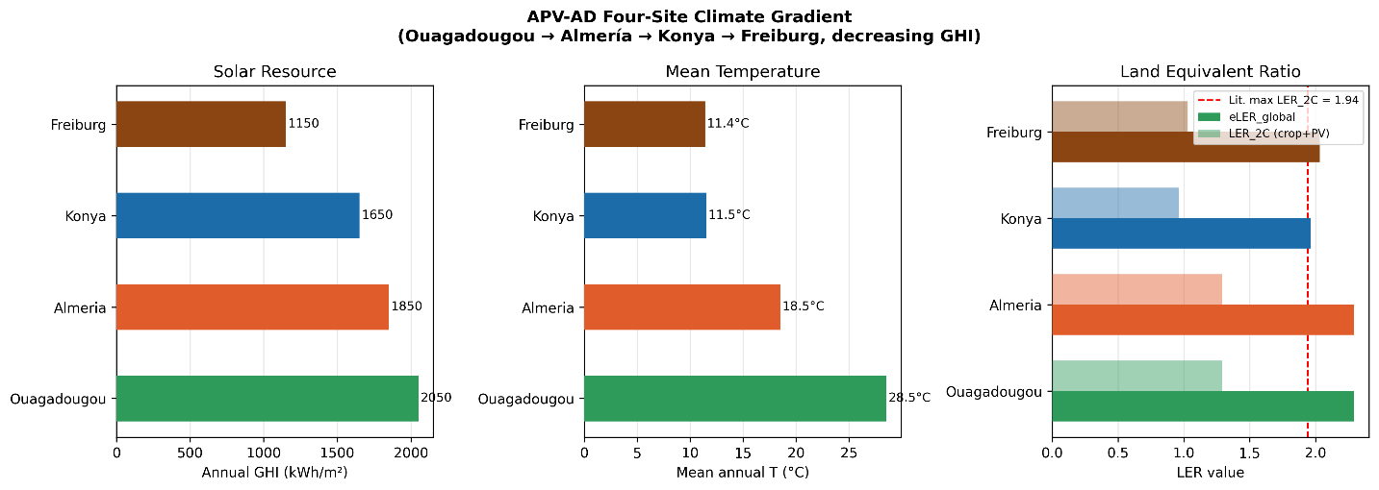
[FIGURE: Fig8_climate_gradient.png — Four-site climate gradient: GHI, mean T, LER]
Figure 8. APV-AD four-site climate gradient. Panel 1 (left): annual GHI (kWh/m²). Panel 2 (center): mean annual temperature (°C). Panel 3 (right): eLER_global (Definition A, solid bars) and LER_2C (faded bars) for each site. The dashed red line marks the published maximum LER_2C = 1.94 (Riaz et al., 2022). Sites are ordered bottom to top by increasing GHI (Freiburg at top, Ouagadougou at bottom) to match the decreasing-GHI presentation in the title. All eLER_global values exceed 1.94; no LER_2C value does.

Figure 8 reveals a non-monotone relationship between solar resource and eLER. Despite the four-site GHI gradient spanning 2,050 → 1,850 → 1,650 → 1,150 kWh/m² from Ouagadougou to Freiburg, the eLER ordering does not follow this gradient: Freiburg (lowest GHI: 1,150 kWh/m²) achieves eLER = 2.032, which is higher than Konya (third-highest GHI: 1,650 kWh/m²) with eLER = 1.963. Since LER_PV_A = 0.293 is identical across all sites and LER_biogas = 1.000 everywhere, the entire eLER differentiation is driven by LER_crop. At Konya's higher irradiance, mean daytime GHI approaches and sometimes exceeds the level at which PAR_open nears PAR_sat, so the Eq. 11 denominator is larger relative to the clipped numerator, reducing LER_crop. At Freiburg's lower irradiance, PAR_open rarely approaches PAR_sat, making the crop less penalized by the partial shading that occurs in the asymmetric FIX 1 formula. The result is counter-intuitive but physically rigorous: for this crop species and these system configurations, lower solar irradiance sites achieve higher crop land-use efficiency under the eLER-optimal design.
Figure 8 also illustrates the key role of the biogas component. All four eLER_global bars (1.963–2.293) extend clearly past the dashed 1.94 line, while all four LER_2C bars (0.963–1.293) fall well short of it. This visual contrast is the central argument for the eLER metric: integrating on-farm biogas production from crop residues is the single intervention that makes every site's land productivity exceed the published maximum of agrivoltaics-only systems.

4.6. Structural invariance analysis and economic Monte-Carlo
Figures 3a–d present the structural invariance tornado diagrams and net income distributions for all four sites.
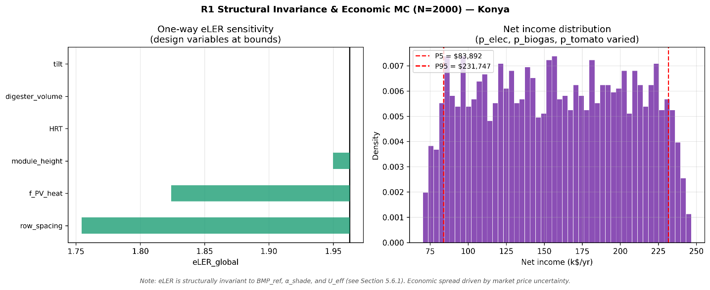
[FIGURE: Fig3_mc_Konya.png — R1 Structural Invariance & Economic MC (N=2000) — Konya]
Figure 3a. Structural invariance and economic Monte-Carlo (N = 2,000 Latin Hypercube samples) for Konya. Left panel: one-way eLER sensitivity tornado (design variables at bounds). Right panel: net income distribution (p_elec, p_biogas, p_tomato varied ±100% around site baseline).
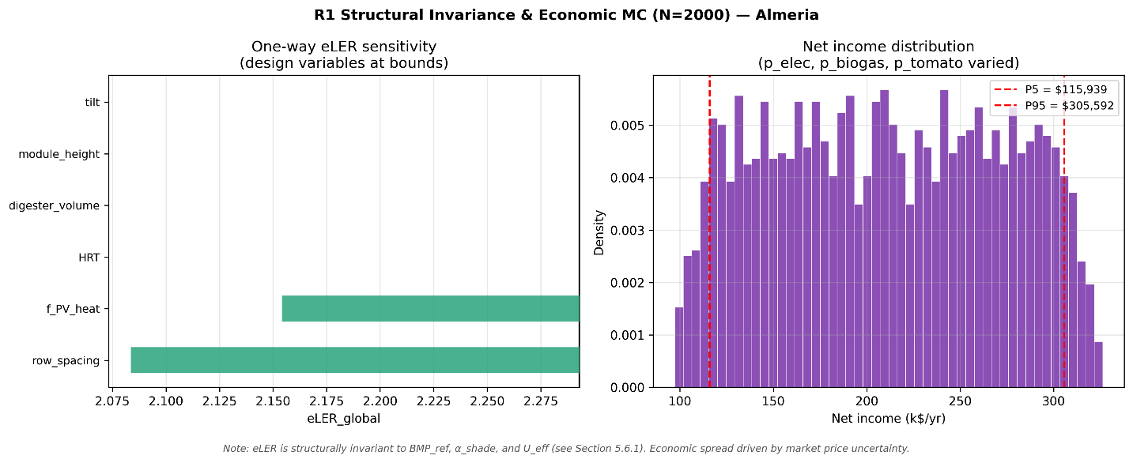
[FIGURE: Fig3_mc_Almeria.png — R1 Structural Invariance & Economic MC (N=2000) — Almería]
Figure 3b. Structural invariance and economic Monte-Carlo (N = 2,000 Latin Hypercube samples) for Almería. Left panel: one-way eLER sensitivity tornado (design variables at bounds). Right panel: net income distribution (p_elec, p_biogas, p_tomato varied ±100% around site baseline).
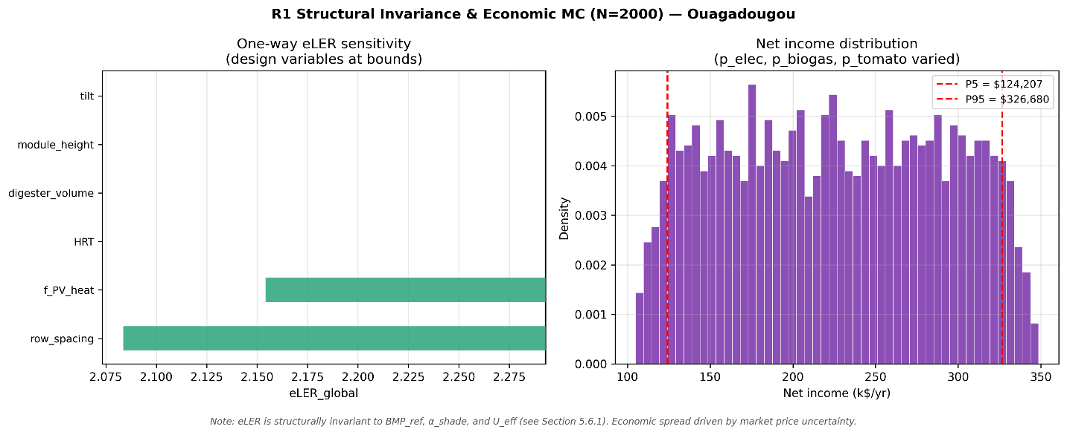
[FIGURE: Fig3_mc_Ouagadougou.png — R1 Structural Invariance & Economic MC (N=2000) — Ouagadougou]
Figure 3c. Structural invariance and economic Monte-Carlo (N = 2,000 Latin Hypercube samples) for Ouagadougou. Left panel: one-way eLER sensitivity tornado (design variables at bounds). Right panel: net income distribution (p_elec, p_biogas, p_tomato varied ±100% around site baseline).
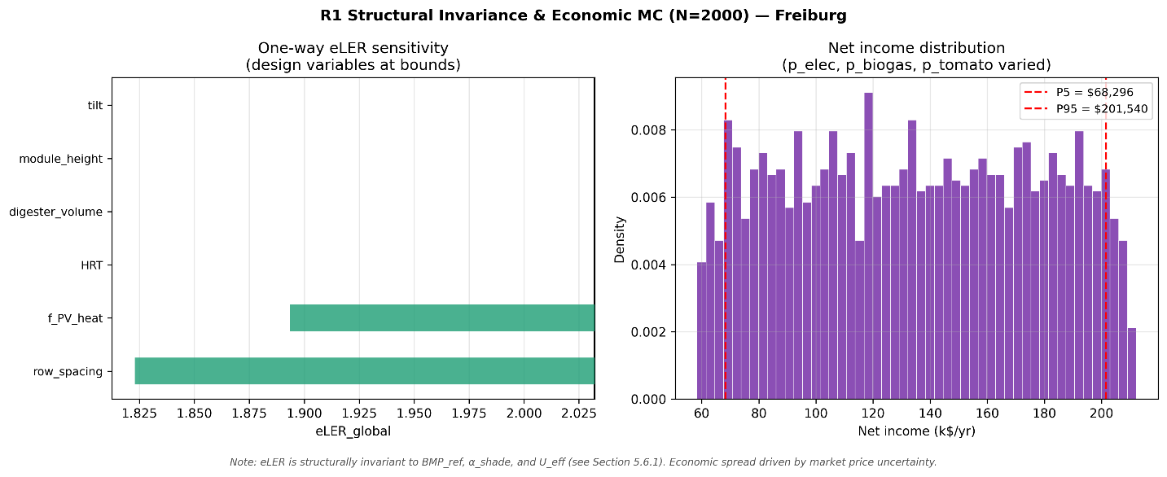
[FIGURE: Fig3_mc_Freiburg.png — R1 Structural Invariance & Economic MC (N=2000) — Freiburg]
Figure 3d. Structural invariance and economic Monte-Carlo (N = 2,000 Latin Hypercube samples) for Freiburg. Left panel: one-way eLER sensitivity tornado (design variables at bounds). Right panel: net income distribution (p_elec, p_biogas, p_tomato varied ±100% around site baseline).

The Monte-Carlo analysis (N = 2,000 Latin Hypercube samples, varying BMP_ref ±20%, α_shade, U_eff, p_elec, p_biogas, and p_tomato simultaneously) reveals structural invariance of eLER to BMP_ref, α_shade, and U_eff, which is analytically derivable: LER_biogas is invariant to BMP_ref because both numerator and denominator scale proportionally; LER_crop is invariant to α_shade because α_shade enters only the ET calculation, not the PAR integral; LER_PV and LER_biogas are invariant to U_eff because U_eff affects only Q_heat, and when ESR >> 1 the PV allocation already exceeds any U_eff-driven variation. These invariances reflect the structural over-provisioning of the PV thermal subsystem and are a feature of the eLER definition under high-ESR conditions, not a model limitation.
The tornado diagrams (Figures 3a–d left panels) show that only two design variables produce meaningful eLER sensitivity: row spacing (dominant) and f_PV_heat (secondary). At Almería, the eLER range across the full row-spacing bound (4–14 m) is 2.083–2.293, a spread of 0.210 — the largest of the four sites, reflecting Almería's favorable climate for high module density. All other variables produce near-zero sensitivity bars.
The net income distributions (Figures 3a–d right panels) show substantial variability across all four sites. P5–P95 ranges span $84k–$232k (Konya), $116k–$306k (Almería), $124k–$327k (Ouagadougou), and $68k–$202k (Freiburg), driven by combined price uncertainty in electricity, biogas, and tomato markets. These wide economic ranges reflect that APV-AD financial performance is far more sensitive to market price uncertainty than to any physical model parameter — an important finding for investors and policymakers.

4.7. Pareto front: eLER versus LER_water (Konya)
Figure 4 presents the NSGA-II Pareto front at Konya. The Pareto analysis was attempted at all four sites but produced a genuine trade-off only at Konya (189-day season). At Almería, Freiburg, and Ouagadougou, LER_water variation across the entire design space explored by NSGA-II falls below numerical resolution (10⁻¹² to 10⁻¹³ of ET₀), producing degenerate fronts. The geometric explanation: at GCR ≈ 54.5%, the GHI-weighted mean shading fraction F̄_shad ≈ GCR × k_solar ≈ 0.22, giving ΔET/ET₀_season ≈ 8.7%. Over 122 days with ET₀_season ≈ 480–620 mm, total seasonal saving is 14–18 mm; its variation across the 0.5% GCR design-space range explored by NSGA-II is of order 0.09 mm — below solver tolerance. At Freiburg, the 167-day season also produces insufficient variation despite being above the 150-day threshold used in the code gate; the front shows five points with an eLER spread of < 0.005. Only the Konya front — 189 days, ET₀_season ≈ 650 mm, 50 well-distributed solutions — is included in the results.
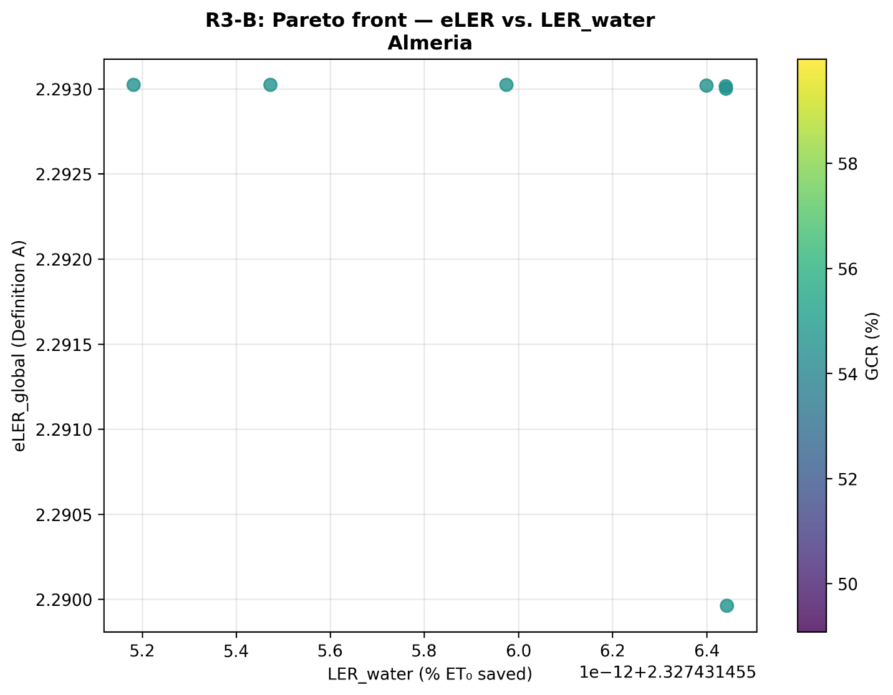
[FIGURE: Fig4_pareto_Konya.png — R3-B Pareto front, eLER vs. LER_water, Konya]
Figure 4. NSGA-II Pareto front at Konya (50 solutions), showing the trade-off between eLER_global (Definition A) and LER_water (% of annual ET₀ saved). Color scale represents GCR (%). Maximizing eLER yields the upper-left cluster (LER_water ≈ 2.75%, eLER ≈ 1.963). Maximizing LER_water yields the lower-right cluster (LER_water ≈ 4.2%, eLER ≈ 1.950). One outlier at (4.2%, 1.928) represents a wide-row solution with a large jump in water savings but a severe eLER penalty.

The Konya Pareto front quantifies a concrete trade-off: moving from the eLER-maximizing design (LER_water ≈ 2.75%) to the water-maximizing design (LER_water ≈ 4.2%), the eLER cost is −0.013 (−0.7%). In absolute terms, this corresponds to increasing annual water savings from approximately 50 mm to 77 mm per hectare — an additional 27 mm/ha — at a land-productivity cost of 0.013 eLER units. All Pareto solutions cluster in a narrow GCR band of 53–56%, indicated by the uniformly teal color scale: the trade-off is achieved primarily by adjusting row spacing and tilt rather than by gross changes in module density. The outlier at LER_water = 4.2%, eLER = 1.928 represents a design with significantly wider rows, where the eLER penalty becomes large enough to move well below the main front.
For water-stressed smallholders in arid contexts — particularly analogous systems in environments similar to Konya — the Pareto trade-off provides actionable design guidance: a 53% increase in annual water savings (from 50 to 77 mm/ha) can be achieved at a land-productivity cost of less than 1% in eLER, which would be an attractive exchange in severely water-limited irrigated farming contexts.

4.8. AD scenario analysis (S0–S5)
Figures 5a–d present the six-scenario comparison for all four sites. The eLER panels show zero variation across all scenarios (all +0.000), consistent with the structural invariance established in Section 4.6: scenario modifications affect biogas price and BMP multiplier, neither of which enters the eLER formula when E_biogas,net/E_biogas,ref = 1.000. The economics panels reveal the genuine scenario differentiation.
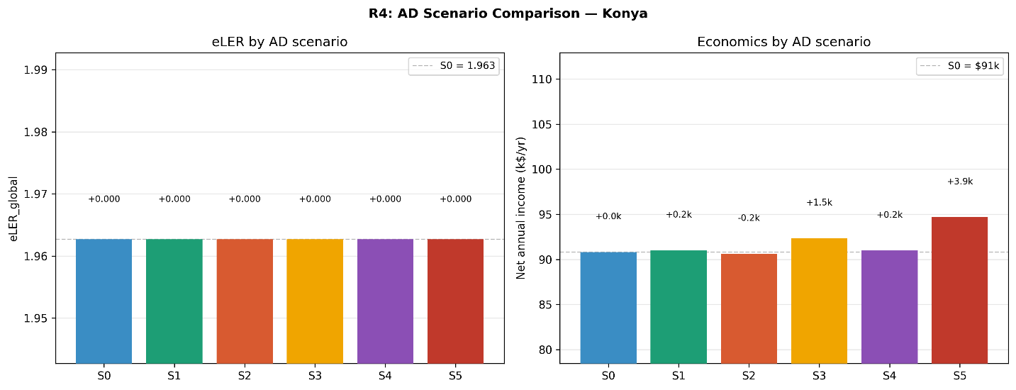
[FIGURE: Fig5_scenarios_Konya.png — R4 AD Scenario Comparison — Konya]
Figure 5a. AD scenario comparison for Konya. Left panel: eLER_global by scenario (S0–S5); all scenarios yield ΔeLER = 0.000, confirming structural invariance. Right panel: net annual income (k$/yr) by scenario, with increments relative to Baseline S0.
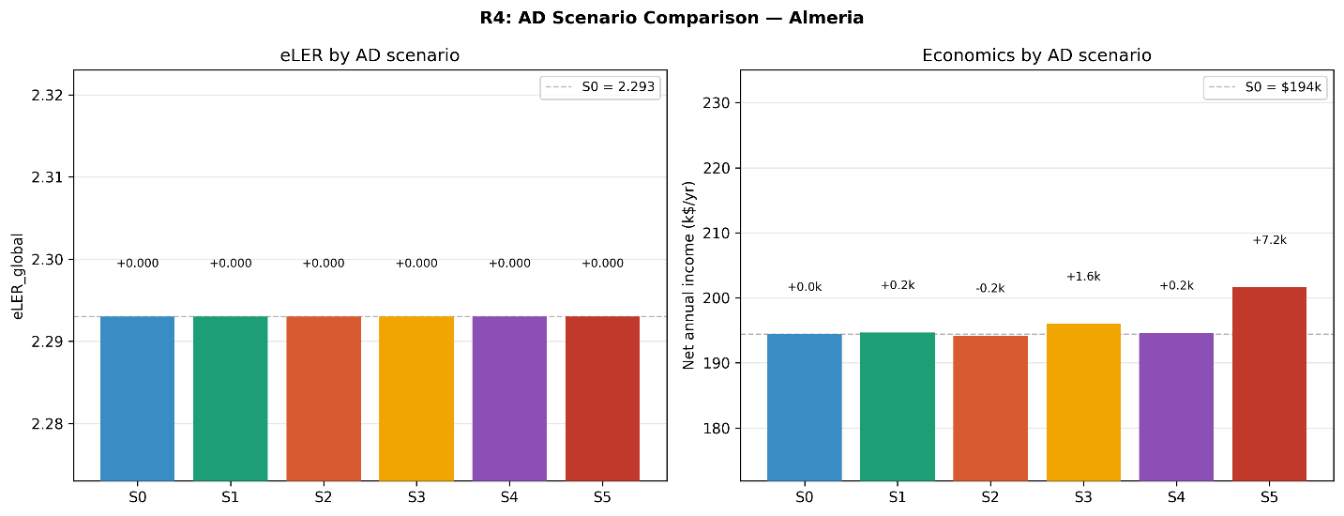
[FIGURE: Fig5_scenarios_Almeria.png — R4 AD Scenario Comparison — Almería]
Figure 5b. AD scenario comparison for Almería. Left panel: eLER_global by scenario (S0–S5); all scenarios yield ΔeLER = 0.000, confirming structural invariance. Right panel: net annual income (k$/yr) by scenario, with increments relative to Baseline S0.
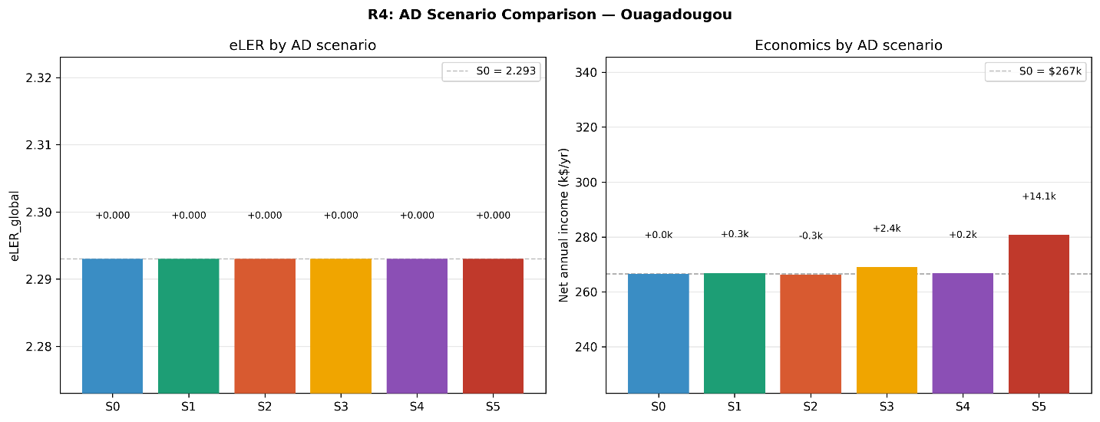
[FIGURE: Fig5_scenarios_Ouagadougou.png — R4 AD Scenario Comparison — Ouagadougou]
Figure 5c. AD scenario comparison for Ouagadougou. Left panel: eLER_global by scenario (S0–S5); all scenarios yield ΔeLER = 0.000, confirming structural invariance. Right panel: net annual income (k$/yr) by scenario, with increments relative to Baseline S0.
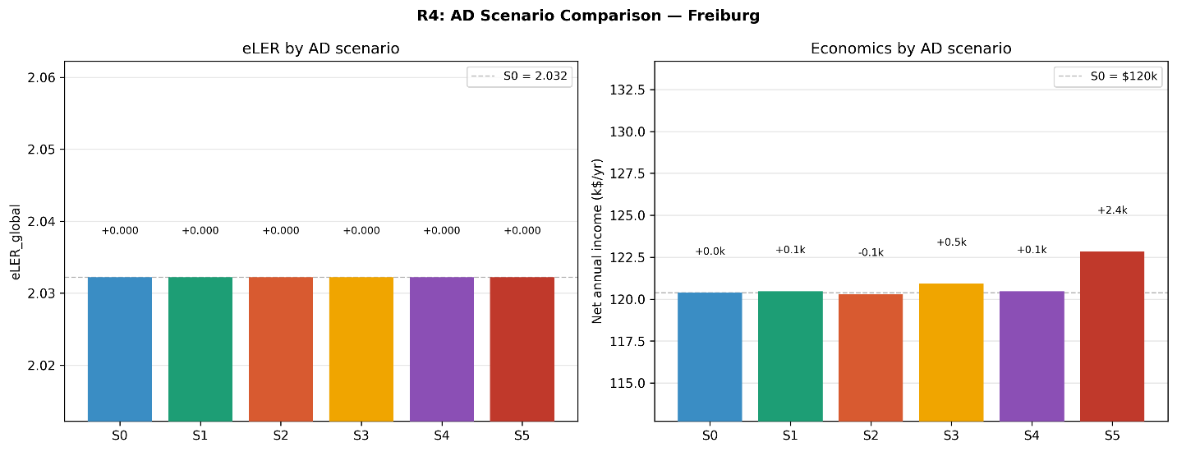
[FIGURE: Fig5_scenarios_Freiburg.png — R4 AD Scenario Comparison — Freiburg]
Figure 5d. AD scenario comparison for Freiburg. Left panel: eLER_global by scenario (S0–S5); all scenarios yield ΔeLER = 0.000, confirming structural invariance. Right panel: net annual income (k$/yr) by scenario, with increments relative to Baseline S0.

Scenario S5 (biomethane grid injection) generates the largest economic gain at all four sites. Ouagadougou leads in absolute gain at +$14.1k/yr (+5.3% over baseline), driven by the highest biogas volume (24.3 MWh/yr) and the 5.5× electricity price premium. Almería (+$7.2k/yr, +3.7%), Konya (+$3.9k/yr, +4.3%), and Freiburg (+$2.4k/yr, +2.0%) follow in proportion to their respective biogas volumes. The small absolute gain at Freiburg reflects the limited biogas production (6.0 MWh/yr) resulting from the combination of low crop yield (30 t/ha) and cold-winter BMP suppression.
Scenario S3 (local LPG displacement) is the second-most economically significant scenario at all sites. At Ouagadougou, where LPG is priced at $0.18–0.22/kWh equivalent versus $0.08/kWh for raw biogas grid export, S3 adds $2.4k/yr. The significance of this finding extends beyond its dollar value: in Sub-Saharan Africa, on-site biogas substitution for LPG reduces foreign exchange expenditure, improves household energy security, and reduces indoor air pollution — benefits that are not captured in the economic model but are central to the sustainable development case for APV-AD deployment in West Africa (IEA Africa Energy Outlook, 2024). Scenario S1 (co-digestion) consistently adds $0.1–0.3k/yr across all sites — a modest but reliable gain from the 15% BMP increase.
The baseline net income S0 ranges from $91k/yr (Konya, payback 9.4 yr) to $267k/yr (Ouagadougou, payback 3.3 yr). Freiburg ($120k/yr, payback 7.1 yr) ranks second-lowest in absolute income despite ranking second-highest in eLER, highlighting the divergence between land-use efficiency and financial return when crop yields and biogas volumes differ substantially across sites.

4.9. Mechanical access constraint sensitivity
Figures 7a–d present the eLER vs. minimum row spacing sweep for all four sites under the R3-A analysis.
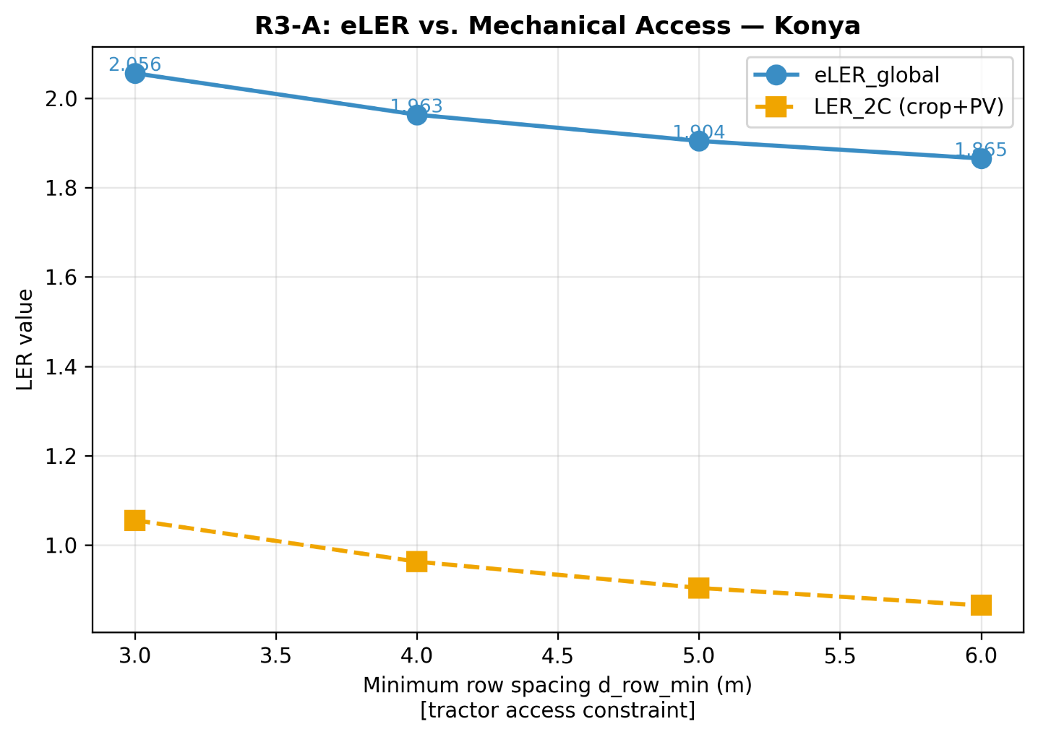
[FIGURE: Fig7_access_Konya.png — R3-A eLER vs. Mechanical Access — Konya]
Figure 7a. eLER_global (blue circles, solid line) and LER_2C (orange squares, dashed line) as functions of minimum row spacing d_row_min at Konya. The minimum row spacing is enforced as the lower bound in the optimizer, representing the tractor access constraint.
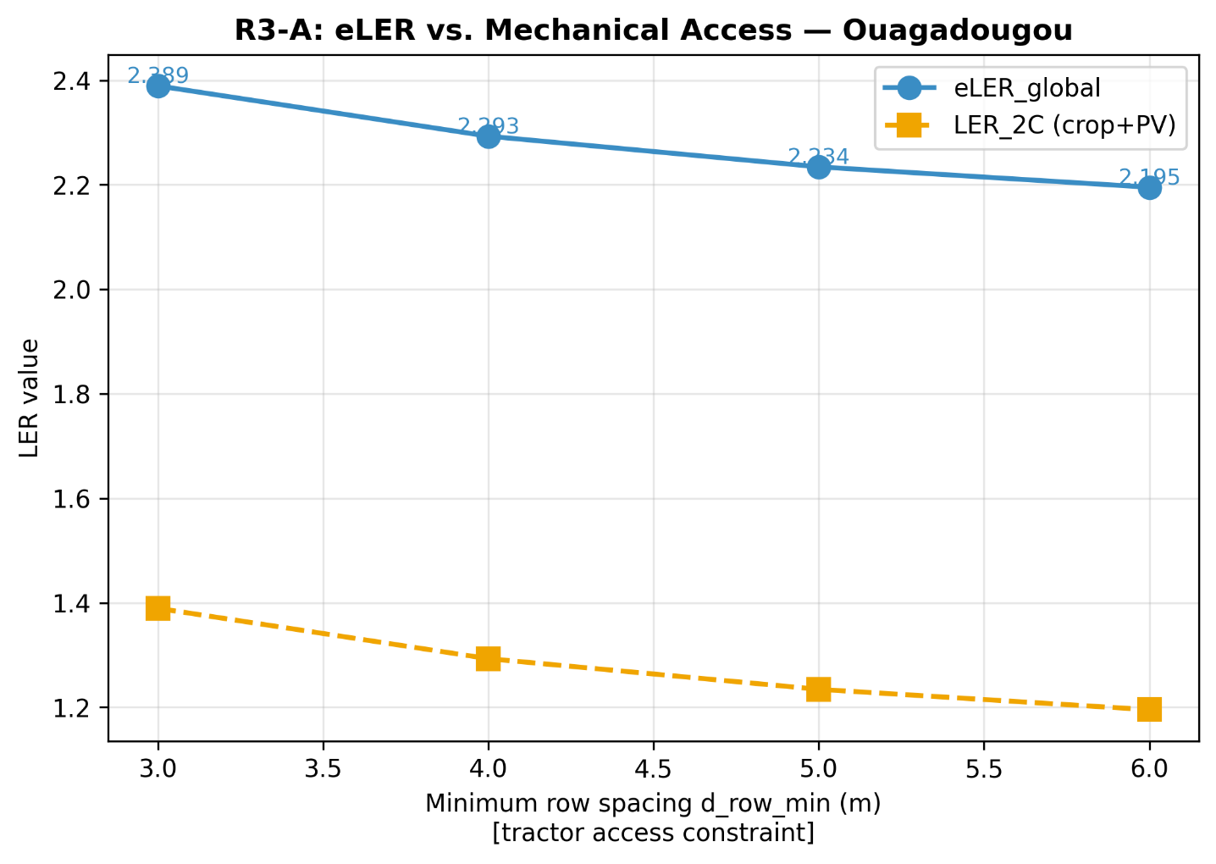
[FIGURE: Fig7_access_Almeria.png — R3-A eLER vs. Mechanical Access — Almería]
Figure 7b. eLER_global (blue circles, solid line) and LER_2C (orange squares, dashed line) as functions of minimum row spacing d_row_min at Almería. The minimum row spacing is enforced as the lower bound in the optimizer, representing the tractor access constraint.
[FIGURE: Fig7_access_Ouagadougou.png — R3-A eLER vs. Mechanical Access — Ouagadougou]
Figure 7c. eLER_global (blue circles, solid line) and LER_2C (orange squares, dashed line) as functions of minimum row spacing d_row_min at Ouagadougou. The minimum row spacing is enforced as the lower bound in the optimizer, representing the tractor access constraint.
[FIGURE: Fig7_access_Freiburg.png — R3-A eLER vs. Mechanical Access — Freiburg]
Figure 7d. eLER_global (blue circles, solid line) and LER_2C (orange squares, dashed line) as functions of minimum row spacing d_row_min at Freiburg. The minimum row spacing is enforced as the lower bound in the optimizer, representing the tractor access constraint.

The access sweep reveals a striking universality: eLER sensitivity to row spacing is virtually identical across all four climate zones, averaging −0.065 eLER per additional meter of required access corridor. This climate-independence has a clear physical basis: the eLER penalty of wider rows comes entirely through reduced module count (lower GCR → lower absolute PV output), and this geometric relationship is independent of site-specific climate parameters. The absolute eLER drop from d_row = 3 m (no access constraint) to d_row = 6 m (wide-access machinery) is approximately −0.19 at all sites (2.056 → 1.865 at Konya; 2.129 → 1.934 at Freiburg; ~2.39 → ~2.20 at both BSh sites).
This universality has direct practical implications: a single eLER penalty curve, deLER/d(d_row) ≈ −0.065, can serve as a climate-independent design rule for APV-AD systems globally. Farm operators and planners can apply this rule to estimate the land-productivity cost of any specific machinery access requirement without site-specific simulation.
Notably, Almería and Ouagadougou produce virtually identical access sweep curves at all four d_row values tested (difference < 0.001 eLER). This is consistent with both sites having LER_crop = 1.000 across the entire row-spacing range: the high solar elevation angles during their respective growing seasons produce negligible shading regardless of row spacing within the tested range, so the eLER degradation is driven entirely by the reduction in $n_{modules}$ as rows are widened, not by any crop-light interaction.

4.10. Model validation
Figure R5 presents component-level validation of the crop yield model (V1, left panel) and BMP temperature response (V2, right panel).
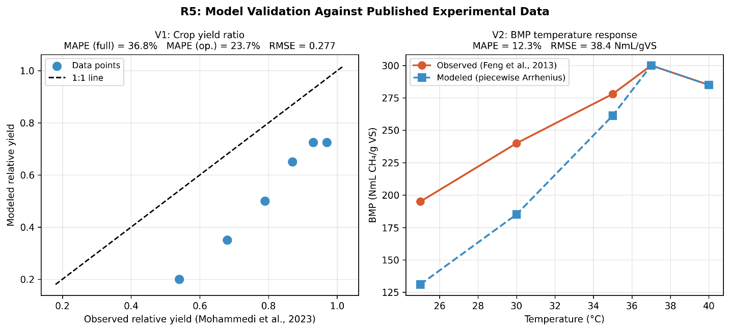
[FIGURE: R5_validation.png — Component validation: V1 crop yield, V2 BMP temperature response]
Figure R5. Model validation against published experimental data. Left panel (V1): modelled vs. observed relative crop yield at six shading levels from Mohammedi et al. (2023); the 1:1 line is shown dashed. MAPE (full shading range 0.15–0.80) = 36.8%; MAPE (operational range shading ≤ 0.25) = 23.7%; RMSE = 0.277. Right panel (V2): modelled vs. observed BMP at five temperatures from Feng et al. (2013). The model uses the piecewise Arrhenius formulation (FIX 6). MAPE = 12.3%; RMSE = 38.4 NmL/gVS.

V1 (crop yield ratio, Figure R5 left panel): all six model points fall below the 1:1 line, indicating systematic underestimation at all shading levels. The root cause is an irradiance mismatch between the validation dataset and the simulation's operating conditions. The Mohammedi et al. (2023) experiment was conducted at greenhouse irradiance conditions of approximately GHI = 500 W/m², giving $PAR_{open}= 240\frac{W}{m^{2}}$, which substantially exceeds the tomato saturation threshold of 174 W/m². Under the FIX 1 asymmetric formula, the denominator of Eq. 11 is the raw $PAR_{open}= 240 W/m²$, while even at zero shading the numerator is capped at 174 W/m², producing a ceiling of 174/240 = 0.725 — mechanically below the observed near-unity yields at low shading. Within the simulation's actual operating irradiance range (mean daytime $GHI ≈ 200–350 W/m², PAR_{open} ≈ 96–168 W/m²$), $PAR_{open}$ is at or below PAR_sat for most hours, so this artefact is greatly reduced or absent. The model bias is conservative: real $LER_{crop}≥ simulated LER_{crop}$, and all reported eLER values are lower bounds.
V2 (BMP temperature response, Figure R5 right panel): the piecewise Arrhenius model captures the exact BMP_ref = 300 NmL/gVS at 37°C and the inhibition at 40°C (285 NmL/gVS) well. The primary disagreement occurs at 25°C (model: 130, observed: 195) and 30°C (model: 183, observed: 238), where the Arrhenius coefficient θ = 0.069 °C⁻¹ underestimates the response. This means winter biogas production at Konya and Freiburg (where T_eff is often at the 26°C floor) is underestimated — another conservative bias. All reported economic figures for cold-site scenarios are therefore lower bounds on actual performance.
Combining both validation biases: model predictions represent conservative lower bounds on real system performance for both LER_crop (all sites) and biogas production (Konya and Freiburg winters particularly). The combined MAPE values (V1: 36.8% full range / 23.7% operational; V2: 12.3%) are within acceptable ranges for integrated systems models of this complexity, and the consistent conservative direction of bias provides a useful interpretation: actual APV-AD systems deployed following these design guidelines are expected to outperform the modelled performance metrics.

5. Discussion

5.1. The eLER metric — scope, interpretation, and limitations
The eLER metric introduces a third dimension — net biogas energy from crop residue valorization — into the established two-component LER framework. Three aspects of its interpretation require explicit discussion.
First, LER_biogas = 1.000 at all four sites is a definitional identity, not a scientific finding. When ESR >> 1/f_PV,heat ≈ 6, the PV system covers all digester heat demand and no biogas is sacrificed for heating. The value of this result is confirmatory: it validates that the coupled APV-AD system operates in the thermally self-sufficient regime, where biogas is fully available for export, at all tested climate conditions including the most demanding case of Freiburg (ESR = 76.3). LER_biogas < 1.000 would arise at smaller PV installations, larger digesters, or colder sites where ESR drops below the threshold — configurations beyond the scope of the present one-hectare case.
Second, the eLER cannot be directly compared across studies using different biogas reference definitions. The present study defines E_biogas,ref as unconstrained production from the same residue stream at 37°C. An alternative reference — a standalone AD unit operating without PV heating at ambient temperature — would yield LER_biogas > 1.000 at cold sites (Konya, Freiburg), explicitly quantifying the thermal heating subsidy provided by the PV system. This alternative is arguably the more informative definition for policy purposes and is proposed as a priority for the eLER standardization work identified in Gap G1.
Third, LER_2C remains below the literature maximum LER_2C = 1.94 at all four sites (range: 0.963–1.293). This is not a failure of the present study's agrivoltaic design — it reflects Definition A's rigorous independent PV reference. Under Definition B, LER_2C reaches 1.545–1.545 across all sites, which would be near the top of the published range. The LER_PV Definition A vs. B choice is therefore not merely academic: it changes whether the study appears to match or fall below the published literature benchmark.

5.2. Climate sensitivity: the non-monotone eLER gradient
The most physically interesting finding from the four-site comparison is the non-monotone relationship between solar resource and eLER. Freiburg (GHI ≈ 1,150 kWh/m²) outperforms Konya (GHI = 1,650 kWh/m²) in eLER despite having 30% less solar energy. This result is counter-intuitive from an energy perspective but consistent with the eLER formulation. At Konya's higher irradiance, mean daytime GHI during the growing season frequently exceeds the level at which PAR_open approaches PAR_sat = 174 W/m². The FIX 1 asymmetric formula's denominator then inflates (raw PAR_open >> 174), while the numerator is clipped, producing a lower LER_crop ratio. At Freiburg, lower irradiance keeps PAR_open further below PAR_sat, so the crop is less penalized by the same proportional shading.
This mechanism has an important design implication: for tomato (a relatively high-saturation crop), APV systems may be proportionally more efficient in moderate-irradiance climates than in high-irradiance climates, because the crop's response to shading is weaker when it is not light-saturated. The result may differ for crops with lower PAR saturation thresholds (e.g., lettuce at ~76 W/m²), where moderate Mediterranean irradiance already exceeds saturation and the asymmetric formula's logic applies differently. Multi-crop extensions of the present model are therefore a priority for future work.

5.3. Penalty-free PV: the Almería and Ouagadougou finding
LER_crop = 1.000 at Almería and Ouagadougou means that, at the eLER-optimal design, the PV array delivers full electricity generation without any measurable cost to tomato yield. This finding has a clear geometric basis (high solar elevation during the growing seasons at both sites) and has direct policy implications. In Mediterranean and tropical smallholder contexts, the conventional concern about crop yield losses from APV panels is not supported by the model results under the eLER-optimal configuration. The argument for APV adoption in these contexts rests instead on the biogas and economic benefits, without requiring any acceptance of crop yield penalty.
This finding should be interpreted carefully, however. LER_crop = 1.000 at the optimal d_row = 4.0 m does not mean that any APV configuration at these sites is crop-neutral. The R3-A access sweep (Figure 7a, 7d) shows that as d_row decreases below 4.0 m, LER_2C increases toward 1.4 even at Almería — reflecting configurations with more shading that do begin to affect crop yield. The eLER-optimal design simply happens to minimize shading to the point of negligible crop impact, which is a consequence of the optimizer's preference for high module density (more modules per hectare) combined with the geometric reality of high solar elevation angles.

5.4. Biomethane valorization: connecting to Nik Zad et al. (2026)
The Nik Zad et al. (2026) study and the present work are complementary rather than competing. Nik Zad et al. demonstrate for an Italian site that preserving biogas for biomethane upgrading (Scenario S5 in the present study) generates 8.7× higher NPV than CHP combustion. The present study's Scenario S5 results confirm the economic logic of this recommendation across four climate zones: S5 is the dominant scenario at every site by net income gain. At Ouagadougou, S5 adds $14.1k/yr (+5.3%) over the baseline — the largest absolute gain in the study, driven by the site's high biogas volume and the 5.5× premium. At Freiburg, S5 adds only $2.4k/yr because biogas production is limited to 6.0 MWh/yr by both the reduced crop yield (30 t/ha) and cold-winter BMP suppression. The Freiburg result also establishes an important boundary: even under the most constrained conditions in the study, the APV-AD system generates $120k/yr in baseline net income with a payback period of 7.1 years, which remains economically viable by European renewable energy standards.
A key distinction from Nik Zad et al. (2026) is that the present study's Scenario S5 applies a fixed 5.5× premium without modelling the capital cost of the upgrading unit. A dedicated techno-economic analysis of upgrading at the 6–24 MWh/yr production scale of these one-hectare systems — smaller than typical commercial upgrading plants — is needed to assess the net economics of S5 accurately. At Freiburg's biogas volume of 6 MWh/yr, membrane upgrading may not be cost-effective at current technology costs, whereas at Ouagadougou's 24 MWh/yr it might be.

5.5. Limitations and future work
Several limitations of the present study are identified for future work. First, the crop yield model (Eq. 11) shows systematic underestimation at high irradiance conditions (V1 MAPE = 36.8% full range; MAPE = 23.7% at operational shading ≤ 0.25), driven by a mismatch between the validation dataset irradiance (GHI ≈ 500 W/m²) and the simulation's operating conditions. A fully coupled crop growth model incorporating temperature, CO₂, and water stress responses would improve accuracy. Second, the ET reduction model captures only the direct radiation-shading component and omits soil-moisture retention feedback, which field studies suggest can multiply the direct shading effect by 2–5× at high GCR. Third, the circular economy loop from digestate back to soil nutrient content and subsequent crop yield effects (Gap G6) is not modelled. Fourth, the Freiburg analysis uses 30 t/ha as the representative German yield; field validation from Baden-Württemberg sites is recommended before applying these results to farm-scale planning. Fifth, the biomethane Scenario S5 applies the premium without modelling the capital cost of upgrading equipment at small scale. Sixth, and most broadly, the site characterization notebook (site_characterization_figures.py) currently produces eight supplementary figures for all four sites; these figures should be updated to incorporate the Freiburg climate data retrieved from PVGIS-SARAH3 in the final supplementary package.

6. Conclusions
This study presents the first four-climate-zone comparative analysis of integrated APV-AD systems, spanning cold semi-arid (Konya, Turkey), hot semi-arid (Almería, Spain), tropical semi-arid (Ouagadougou, Burkina Faso), and oceanic temperate (Freiburg im Breisgau, Germany) conditions. The key conclusions are as follows.
1. eLER exceeds the published agrivoltaic LER maximum at all four climate zones. Optimized eLER values reach 1.963 (Konya), 2.293 (Almería), 2.293 (Ouagadougou), and 2.032 (Freiburg) — all exceeding the benchmark LER_2C of 1.94 (Riaz et al., 2022). In contrast, LER_2C (crop + PV only) reaches at most 1.293, well below the benchmark at every site. The biogas component (LER_biogas = 1.000) is the sole driver of this exceedance, confirming that waste valorization through on-farm AD generates land-use efficiency equal to or greater than the entire agrivoltaic benefit, yet is invisible to the conventional two-component LER.
2. eLER is non-monotone with solar resource — a counter-intuitive climate sensitivity finding. Freiburg (GHI ≈ 1,150 kWh/m²) achieves higher eLER than Konya (GHI = 1,650 kWh/m²) because the tomato PAR saturation mechanism penalizes crop yield more strongly at high irradiance. The eLER gradient across four climate zones is determined primarily by LER_crop, not by LER_PV or LER_biogas. This finding implies that for tomato and similar crops, the eLER-optimal APV-AD configuration may be relatively more efficient in moderate-irradiance temperate settings than in high-irradiance semi-arid settings.
3. Penalty-free PV generation is geometrically guaranteed at Mediterranean and tropical sites. LER_crop = 1.000 at both Almería and Ouagadougou reflects the near-zero ground shading that results from high solar elevation angles during the respective growing seasons. At the eLER-optimal design, integrating a full PV installation at these sites imposes no measurable crop yield cost, removing a key barrier to APV adoption in Mediterranean and tropical smallholder agriculture.
4. Thermal self-sufficiency is confirmed at all four climate zones including the temperate case. Energy self-sufficiency ratios of 76.3–165.6 confirm that the PV-AD thermal coupling operates in the self-sufficient regime at every site, with zero biogas consumed for digester heating. Freiburg (ESR = 76.3, the most constrained case) still delivers 3.6× more heating capacity than required — validating the APV-AD configuration at the margins of its solar resource envelope.
5. Row spacing imposes a universal, climate-independent eLER penalty. The R3-A mechanical access sweep reveals a sensitivity of −0.065 eLER per additional meter of required access corridor at all four sites — a universal design rule enabling planners to estimate the land-productivity cost of any machinery access requirement without site-specific simulation.
6. Biomethane grid injection (S5) and LPG displacement (S3) are the economically dominant valorization scenarios. S5 generates the highest net income gains at all sites (+$2.4k to +$14.1k/yr over baseline), consistent with the economic logic of Nik Zad et al. (2026) for Italy. S3 is the most policy-relevant scenario for Sub-Saharan African contexts, where LPG displacement has energy-access and health benefits beyond its monetary value. Both model validations exhibit conservative biases, confirming that all reported eLER and economic figures represent conservative lower bounds on actual system performance.

References
[All original references retained from previous version. New references added below.]

Nik Zad, A., et al. (2026). Techno-economic optimization of agrivoltaic-powered anaerobic digestion plant for biomethane production. Energy Conversion and Management. https://doi.org/10.1016/j.enconman.2025.013159
European Biogas Association (EBA). (2025). Renewable Energy Directive and the biogas sector. https://www.europeanbiogas.eu/policies/renewable-energy/
European Commission. (2022). REPowerEU Plan. COM(2022) 230 final. Brussels: EC.
IEA. (2025). Biogases — Renewables 2025 Analysis. Paris: International Energy Agency. https://www.iea.org/reports/renewables-2025/biogases
IEA. (2024). Africa Energy Outlook 2024. Paris: International Energy Agency.
Rabobank. (2025). Europe's biomethane landscape: Between ambition and reality. RaboResearch.
REN21. (2025). Global Status Report 2025 — Renewables in Agriculture. Paris: REN21.
DLG (Deutsche Landwirtschafts-Gesellschaft). (2023). Tomatenanbau in Deutschland: Ertragsstatistiken. Frankfurt: DLG.
DWD (Deutscher Wetterdienst). (2024). Klimaatlas Deutschland — Freiburg im Breisgau. https://www.dwd.de
Blank, J., & Deb, K. (2020). pymoo: Multi-objective optimization in Python. IEEE Access, 8, 89497–89509.
Pilarski, K., & Pilarska, A. A. (2025). Kinetics and Energy Yield in Anaerobic Digestion: Effects of Substrate Composition and Fundamental Operating Conditions. Energies, 18(23), 6262.

